Abstract
This thesis examines the relationship between branded augmented reality and its impact on brand attachment and purchase intent. By assessing the impacts of this emerging technology in the branding sphere, I define its effectiveness in creating a lasting relationship between the consumer and the brand, as well as determining any increases in purchase intent as a direct correlation from exposure to the augmented reality app. I implemented L’Oreal Makeup Genius mobile application, an augmented reality technology that directly applies makeup to the user’s face through an iPad screen, to qualitatively measure brand attachment and purchase intent. I used a qualitative analysis of three focus groups – current L’Oreal customers, competitor customers (Almay, Maybelline, NYC Cosmetics, MAC, CoverGirl, Revlon), and non-makeup users. This thesis sets out to assess if brand-self connections and brand prominence, two prongs of brand attachment, increase as a direct result of using branded augmented reality, if purchase intent increases, and best practices for use of the technology.

1. Introduction
The marketing and advertising industries are quickly pursuing augmented reality (AR)as the next frontier of connecting with consumers. These industries are taking the first strides in consumer-focused AR technology and tailoring this emerging technology to meet their needs of engaging with customers and increasing purchase intent. “The marketing and advertising industries are a major economic stakeholder that is not merely taking AR and deploying it for their purposes, rather they are actively dictating the priorities and shaping the technological properties of the technology itself” (Liao, 2014, p. 324). With its interactive nature augmented reality is seen as a newest avenue for experiential marketing (Huang & Liao, 2014). By 2017 it is projected that users will install 2.5 billion mobile AR applications (Schmalstieg, 2011). According to Allied Business Intelligence, Inc., developers invested $670 million in augmented reality applications in 2013. AR and VR investment banking firm Digi-Capital released a report “Augmented/Virtual Reality Report Q1 2016” in which researchers forecasted AR investments to reach $90 billion in 2020, compared to $30 billion in VR (Digi-Capital, 2016).
Augmented reality “superimposes computer-generated images on top of a user’s perception of the real world in real time [and] delivers integrated visual experiences directly related to a place or object that the user views, without any delay” (Gervautz, 2012, p. 26). Augmented reality is becoming increasingly prominent in mobile devices by using technology integrated into the devices, such as cameras, electronic compasses and global-positioning systems (Skeldon, 2011).
In the past five years, brands ranging from McDonald’s (Morrison, 2014) and Lowe’s (Johnson, 2014) to Lucky Charms (Schultz, 2013) and Starbucks (Gianatasio, 2011) have integrated the technology into various mobile campaigns. For example, IKEA created an interactive digital catalog that allowed users to drag catalog furniture items into the real-time space of a room in their home featured on their smartphone or tablet screen and take a screenshot of the furniture in their home. “In this manner, catalogs become more interactive, and by increasing playfulness and convenience they stimulate consumers’ intentions to buy and their impressions of the brand” (Huang & Liao, 2014, p. 287). These augmented reality campaigns are measuring success based on app downloads, sales and engagement.
Marketers are still investigating how strong a consumer’s relationship can grow through interacting with AR and if these digital interactions strengthen brand attachment. Park, MacInnis, and Priester (2006) defined brand attachment “by a strong linkage or connectedness between the brand and the self” (p. 195). Consumers display cognitive and affectively-based brand-self connections as a result of their brand attachment. The brand becomes an extension of the self as an attachment-based commitment develops. Park et al. (2006) writes that qualities of this brand-self relationship developing are “brand loyalty, willingness to pay a price premium, willingness to forgive brand mishaps, devaluation of alternatives, wiliness to not substitute brand for other brands, and positive WOM” (p. 193) Thus, brand attachment is the best measure to analyze how persuasive augmented reality truly is on a consumer’s intent to purchase.
A deep research study has yet to be performed on the relationship among augmented reality, brand attachment and purchase intent. As investment into augmented reality technologies continues to increase, I want to qualitatively study how augmented reality technology in the retail space can foster brand attachment with consumers, thus increasing purchase intent. I also want to explore and understand the qualities (attributes) most resonate with female Millennials about branded AR that may enable marketers to foster increased levels of brand attachment.

- Literature Review
2.1 Augmented Reality
Augmented reality systems have three key dimensions. First, augmented reality combines virtual images with the real world by overlaying text or pictures onto reality. Second, augmented reality includes a three-dimensional registration of digital data, so the digital images and text appear realistic. Lastly, users are able to manipulate and interact with the digital images in real time (Schmalstieg, 2011).
Mobile augmented reality is defined by Alan B. Craig (2013) as “AR that you can take with you wherever you go” (p. 209). The hardware needed to activate augmented reality has the ability to be with users at all times, since it is embedded into smartphones or tablets. Mobile augmented reality has many advantages. Augmented reality exists in the real-world situations like advertisements or geographic areas, so it must be accessible at all times. The use of a facility designated exclusively for augmented reality would not be practical for the omnipresent nature of augmented reality. Mobile augmented reality allows for “ubiquitous learning,” meaning that users can access the technology at anytime, any location and for any need (Craig, 2013, p. 217).
The Van Gogh Museum in the Netherlands created the mobile augmented reality app, Touch Van Gogh (Forsyth, 2011, p. 129). The app includes Van Gogh’s paintings, sketches, letters, information about his life and recent research that gives users a fuller image of the artist. Created by IJsfontein, the tablet app allows users to view the paintings before restoration by dragging their fingers on the screen, pushing away the current image to uncover the original painting. When users bring the tablet up to View from Theo’s Apartment, 1887, they can see the original view that inspired the painting and access more information about the historical significance of the artwork. Through the app users can also scrub away a current painting to find other drafts that Van Gogh hid beneath his final work (App Touch Van Gogh, n.d.).
Two other important advantages of mobile augmented are its low price compared to stationary technology and that many people already have the required hardware in their mobile devices. Mobile augmented reality requires sensors, processing, and highly detailed displays, which are already installed in smartphones and tablets (Craig, 2013, p. 213).
One of the current disadvantages is that users have to download an augmented reality app from each brand to access its technology. There is not a single augmented reality app that works for all instances of augmented reality. Technological constraints limit the amount of available memory and screen space for users to interact with AR. In addition, environmental constraints such as “lighting, humidity, noise, and other environmental conditions” present while users are attempting to access the mobile application cannot always be accounted for by the creators of the technology (Craig, 2013, p. 215). This can cause problems with an AR app’s functionality. Lastly, the frameworks for users to interact with augmented reality are very open-ended, so participants may become confused by the abundance of options and lack of streamlining in use of augmented reality technologies (Craig, 2013).
Global advertising agency Saatchi and Saatchi, mobile specialists at Hyperfactory and the research institute HIT Lab NZ collaborated in 2007 to create the world’s first mobile augmented reality advertising campaign, “Wellington Zoo Close Encounters.” A print advertisement for the Wellington Zoo ran in a city paper for three days, reaching 750,000 people (Craig, 2009, p. 66). The advertisement included a phone number which users could text and receive an AR application to download onto their mobile phones. When the app was open, an individual could point his mobile phone at the printed advertisement, and a virtual zoo animal would appear to climb from the newspaper page. The augmented reality video possessed a high visual quality, simulating the figure on the animal acting in real-time (Schmalstieg, 2011).
The AR campaign led to a 32% growth in attendance at the zoo’s “Close Encounters” exhibit (Craig, 2009, p.66). The ad also generated a large amount of press, and Saatchi and Saatchi won awards for innovative uses of new technology. In 2007 multiple issues existed with adaption of the technology. For example, users could only have mobile phones using a particular operating system. Otherwise, the app was not sent to the user because it could not be accessed (Schmalstieg, 2011). Today, the technology has increased with finer cameras and more technologically advanced hardware, which meet the needs of augmented reality design.
Mobile AR is even more accessible today on smartphones and tablets. An outdoor clothing company in the US, Moosejaw, created a mobile AR app allowing mobile users with the app to “see models in their undergarments when pointing their smartphone or tablet at the catalog” (Gervautz, 2012, p. 30). As a result of the campaign, Moosejaw experienced a 37 percent sales increase, which they attribute to the app’s popularity (Gervautz, 2012).
Furniture retailer IKEA heralded success with their augmented reality catalog campaign launched in 2012. The technology required users to download an app through which they could “position augmented furniture around their home or apartment” (Liao, 2015, p. 321). The app, launched in July 2012, became “the most downloaded branded promotional-purpose app of 2012” (“Augmented”, 2012). IKEA was able to track the app’s usage and found that activity increased by 35% on Sundays (Liao, 2015, p. 321). The app accelerated consumers’ decision making processes by allowing them to accurately visualize the furniture in their homes and take a screenshot of the image. The augmented reality catalog “enhances playfulness and convenience, as well as stimulates consumers’ buying intentions and impressions of a brand” (Huang & Liao, 2013, p. 83).
As tablets, smartphones and other mobile devices increase their technological capacities through sensors, improved processing and high-definition cameras, augmented reality applications and uses are becoming more innovative and varied for marketing and advertising (Gervautz, 2012) (Mobile, n.d.). According to market intelligence firm Tractica, the amount of actively used mobile AR applications will reach 2.2 billion by 2019, a 1630% increase from 135 million actively used downloads in 2014. This will establish a market totaling $1.6 billion for mobile AR apps (Mobile, n.d.).
There are two dominant ways that users interact with mobile augmented reality using their smartphones or tablets. The first, “embodied interaction” uses the mobile device’s movements and the touchscreen to manipulate the virtual objects on the screen. Such movements consist of “navigation, pan-and-zoom by moving the device relative to the scene, actions triggered by changes in the device’s orientation or distance, screen gestures, or tapping on the touchscreen” (Gervautz, 2012, p. 28)
“Tangible interaction” is controlled by moving the known objects that exist in the real world. “Actions can be triggered by the appearance or disappearance of objects in the view, a change in an object’s position and orientation, the proximity of two or more objects, gestures, or a combination of these” (Gervautz, 2012, p. 28) Disney used this interaction technique in its augmented reality coloring books, released in October 2015. Users color an image on a coloring book page. When the user brings a tablet with Disney’s mobile application in use over the colored image, the image becomes three-dimensional on the tablet. The user can move the color book page around to see the three-dimensional image from all angles on the tablet screen (Disney).
2.2 Augmented Reality and Marketing
Researchers have examined a number of augmented reality uses as marketing functions. Media industries like print journalism can leverage augmented reality to “transform and revitalize” storytelling (Liao, 2015, p. 310). Augmented reality browsers allow for users to create content, adding information such as photos or historical information to a particular location, as researched by Liao and Humphreys (as cited by Liao, 2015, p. 310). An example of this is McDonalds’ mobile app McMission featuring augmented reality games to teach customers about McDonalds’ sustainability measures (Sterling, 2013). Augmented reality also provides a platform to engage multiple senses, which marketers can leverage to make advertisements increasingly immersive.
Marketers must decide which aspects are most salient to augment. In marketing campaigns, AR can provide more product information, an interactive and manipulatable viewer experience, and an increased amount of intricate product detail. Various sales chain and marketing implementations for AR include vary from promotional materials to the “after-purchase experience” (Gervautz, 2012, p. 30).
Due to augmented reality’s playfulness and increased engagement with consumers, marketers have leveraged the technology to display additional features of products, interest consumers and ultimately lead to an increase in sales. In 2010 augmented reality company Metaio paired with Lego to create point-of-sale augmented reality displays in retail locations (Liao, 2015). The interactive displays allowed customers to walk up to the screen and hold their Lego package to the camera. The screen featured a 3D model of the set the customer as about to purchase. The marketing stunt led to a 17% increase in global sales at a time when the toy market was in decline.
As consumers are bombarded with promotions, product information and advertisements, augmented reality displays of products can capture customers’ interest and increase their levels of engagement with an advertisement. One experiment by Hidden Creative, a marketing research company, compared the engagement and purchase intent with a 2D display and AR marketing for a toy alongside each other. Customers spent 12 seconds engaged with the 2D display, in contrast to 83 seconds with the AR technology. Using the 2D display, 45% of customers said thy would consider purchasing the product. In comparison, 74% expressed purchase consideration after using AR (Liao, 2015, p. 316). Augmented reality can solve problems of a lack of attention and time spent with expensive advertisements and influence willingness to purchase, even at a premium. Therefore, for marketers augmented reality is a well-suited medium for promoting consumer goods products.
Augmented reality can also ease the process of online shopping by displaying additional qualities of the product to consumers and simulating direct usage of the product. For example, furniture retailer IKEA sent out 210 million copies of their digital interactive catalog to consumers and 600,000 people tested the AR technology in the catalog to look at the appearance of the furniture in their homes (Liao, 2015). The AR technology assuaged any previous reluctance due to size or appearance in a particular environment, therefore making online shopping easier for customers. Because of AR’s realism, customers are able to trust that the product is a good fit for them. The technology also enhances convenience. The IKEA customers were visually able to test out the furniture in the convenience of their homes, before actually purchasing.
Researchers have executed different exploratory studies to hone in on the effects of AR on consumer engagement. Convenience, customer satisfaction and brand attitude were assessed in a focus group study analyzing the effects of Glasses Direct’s augmented reality experiential marketing, conducted by Bulearca (2010). AR increased the participants’ sense of trustworthiness and reliability of Glasses Direct’s AR application. Consumer trust increased because they could test the products without “having it presented to you in an advert,” which made them feel that the brand was “honest” (Bulearca, 2010, p. 245). Increasing feelings of trust with a brand could lead to an increased amount of brand attachment, but this needs to be tested to confirm. Augmented reality also enhanced functional attributes including “time-saving, practicality, and convenience” because the participants felt that they no longer needed to go into the store to try on and purchase the product (Bulearca, 2010, p. 244). Like IKEA, Glasses Direct allowed customers to try on the product before purchasing, and therefore they were able to conveniently test the product, shop online much easier and feel increased levels of trust for the brand.
Augmented reality has also been assessed based on quality attributes, cognitive attributes and user attitude attributes. In a study on virtual apparel try-on simulation using a Kinect for Xbox 360, Yuan, Khan, Farbiz, Yao, Niswar, and Foo (2013) investigated these three attributes through a questionnaire administered after participants used the virtual system. The virtual system administered three scenarios: virtual clothes appearing solely on the virtual figure (scenario A), virtual apparel appearing on the user’s image (most closely associated with augmented reality, scenario B), and virtual clothes on a virtual figure with an image of the user’s face on it (scenario C). Quality Attributes investigated “reliability, accuracy and user centric issues.” Cognitive Attributes measure the mental actions engaged when using the mixed realities system such as “attention, learning, decision making and emotive elements.” Attitude Towards Using attributes measure the attributes as the observed ease of use and practicality of the system. The participants’ rated the Attitude Towards Using attributes most highly in the situation most similar to augmented reality, scenario B. Over half of the participants said that their experience with scenario B was enough to have a high purchase consideration. One participant said, “This definitely beats online shopping experience as I am able to see for myself how the dresses really look like on my body, and not by imagination” (Yuan et al., 2013, p. 1966). Therefore, participants value the augmented reality scenario more highly than traditional online shopping. In Scenario B users also scored highly that they trusted the system and valued it as having high reliability, leading to an increased purchase intent. This data can be used to infer that use of augmented reality in e-commerce and marketing settings can lead to an increased purchase intent and level of trust by the consumer.
Broadly, the technology acceptance model (TAM) can “explain how firms and individuals adopt new technology” (Huang & Liao., 2014, p. 270). T.L. Huang & Liao (2014) used the model to determine which factors influence a sustainable relationship with augmented-reality interactive technology. The TAM asserted a strong positive correlation between consumers’ intentions to engage with interactive technology and “the perceived usefulness and ease of use of the information system” (Huang& Liao, 2014, p. 273). Aesthetics, including “visual appeal” and “entertainment value” are key to engaging users with augmented reality (Huang & Liao, 2014, p. 273). Other aspects that are key to developing a relationship include service excellence and playfulness. Integrating these factors into augmented reality interactive technology will increase its ability to connect with users.
The common problem in the advertising industry is the difficulty in measuring the impact of an advertisement on a consumer. As the augmented reality industry advances, developers are combating this problem by developing suites of analytics to create clear metrics for marketers to quantify engagement with AR applications. BlippAR created a suite named AnalyzAR providing companies a method to “track behavior, location, and interaction patterns in real time” (Liao, 2015, p. 321). Augmented reality companies are moving towards charging customers solely for the metrics, creating a “marketing customization and licensing model” (Liao, 2015, p. 322). One CEO of an AR company states, “We might even create some campaigns for free, but we’ll own the data. So if the company wants to see the metrics, then they’ll have to pay” (as cited in Liao, 2015, p. 321). The marketing industry is driving the evolution of augmented reality models for advertising according to their demand for metrics.
Michael Gervautz (2012) from Qualcomm Research writes, “The largest application opportunity for AR is interactive marketing, advertising and sales. An AR marketing campaign might include new car models appearing on flyers, cereal boxes featuring games, ketchup bottles displaying recipes, or magazine covers transforming into videos. Different types of AR marketing can add value to the product itself, either in the form of an enhanced product or a more engaging viewer experience. AR lets brands associate their digital content directly with their product or advertising material. Thus, the entire marketing and sales chain can use AR, including advertising material, in-store navigation, in-store experience, product experience, salesperson support and after-purchase experience” (p. 30). Augmented reality has various opportunities to engage consumers with brands with its ubiquitous nature.
AR is taking strides to make its platforms increasingly interactive and participatory. “Augmented Reality 2.0” explores the advent of mobile and web applications deployed on a global scale and simultaneously used by a large amount of people, creating the combination of Web 2.0 and augmented reality. User-generated content would be integrated into location-based mobile augmented reality experiences, creating a network for creativity, communication, collaboration and flow of information sharing. As users would move through the real world, they would experience a digital overlay of pertinent information appearing on their mobile phones (Schmalstieg, 2011).
With its many complexities and capabilities, augmented reality has become an important tool for marketers to leverage to increase consumer engagement. One aspect of consumer interaction that augmented reality could strengthen is brand attachment. Brand attachment is defined as “the strength of the cognitive and affective bond connecting the brand with the self” (Park et al., 2010, p. 4). Brand attachment occurs when a brand becomes integrated as a piece of the consumers’ self-concept. The process of brand attachment begins when a consumer recognizes that a brand aids their self concept in one of three distinct ways. The brand “(1) gratifies the self through hedonic and aesthetic qualities, (2) enables the self by fostering a sense of efficacy and control, (3) enriches the self by providing symbolic meanings that define one’s identity and (4) can do so reliably and with the customer’s interests at heart” (Park et al., 2010, p. 23). After consumers establish trust for a brand, they exhibit their feelings of attachment by displaying the brand, efforts to be included in a brand community with others who are also attached to the brand, or expressing love for the brand (Park et al., 2010). Stating that a brand is “’mine,’ ‘part of me,’ ‘reflecting me,’ ‘expressing me,’ ‘an extension of myself,’ ‘aesthetically appealing to me,’ or ‘emotionally relating to me’” all show a connection between the brand and the self (Park et al., 2010, p. 5). Once the attachment-based commitment is established, consumers reflect their relationship with the brand through brand loyalty, a willingness to pay a price premium, willingness to forgive brand mishaps, devaluation of alternatives, willingness to not substitute a brand for other brands and positive word of mouth (Park et al., 2010, p. 2). As a result, the brand captures higher brand equity, leading to lower marketing costs, the ability to increase the price point, and higher sales.
Starbucks leverages brand attachment among its customers well. Its aesthetic elements present in the coffee’s warmth and taste; the retail environment’s comfortable atmosphere, deeming it the third space between home and work; and the peaceful background music enhance feelings of “relaxation and self-indulgence” (Park et al., 2010, p. 13). Starbucks’ effectively appeals to hedonic and aesthetic elements, thus gratifying the self. This strong brand attachment has led to its climbing sales from $4.1 billion in 2013 to $16.45 billion in 2014 in revenue globally (Starbucks).
Augmented reality’s uses are evolving with marketing demands (Liao, 2015). As increasing uses and demands for augmented reality emerge, marketers must decide what methods are best, which qualities are most salient, and which communication channels are most effective for attracting their target audiences, enhancing customer loyalty, and fostering brand attachment.
2.3 Augmented Reality and Makeup
Makeup has a similar impact on brand-self connection. As female-identified individuals apply makeup, self-gratifying aesthetics become apparent as the users feel satisfied with their appearances. “From a dynamic point of view, physical appearance is not simply an immutable attribute, but rather can be altered and managed by individuals to convince others of their value and worth; and to construct, inflate, maintain and defend images of the desired self” (Liu, Keeling, & Hogg, 2012, p. 91). Makeup serves as the tool to alter and disguise qualities of an individual’s physical appearance, and thus portray the ideal image of herself.
Researchers Liu, Keeling and Hogg (2012) performed 26 in-depth interviews with women 19 to 62 years old, spanning a variety of nationalities. One interviewee expressed numerous times how she uses makeup to “make herself feel perfect and flawless” (Liu et al., 2012, p. 93). Without makeup she describes herself as “‘normal’, ‘lazy’, ‘timid’ and ‘vulnerable,” but while wearing cosmetics she uses much stronger words, such as ‘empowered’ (Liu et al., 2012, p. 93). Her explanation of these self-descriptors reflect how closely the self is intertwined with makeup usage. Makeup is used to strengthen people’s self-image, making them feel stronger, more confident and more accepted (Liu et al., 2012).
Researchers also found that a negative correlation exists between frequency of makeup use and “social anxiety”, “perceived incompetence” and “fear of negative evaluation” (Brdar, 1996, p. 47). Therefore, the more often women use makeup, the less often they feel inferior to others or apprehensive in social situations. People become very loyal to their brand of makeup, choosing that brand above all other options, despite a higher price point or or less convenience. People also rave about their makeup products, sharing with friends and family about their newest find. Compliments on appearance are highly valued by female-identified individuals; these positive comments are taken as a reflection of a positive reflection of their identities.
2.4 Augmented Reality, Brand Attachment and Purchase Intent
After analyzing current research, augmented reality has been assessed on a number of qualities. Based on the technology acceptance model, varied levels of cognitively innovative consumers accept augmented reality based on perceived ease of use, perceived usefulness, perceived aesthetics, service excellence and perceived playfulness (Huang & Liao, 2014). Augmented reality can offer a heightened sense of interaction with a brand through product manipulation and personalization. Augmented reality can offer experiential value through presence and “product simulations” (Yuan, 2013). Users trust augmented reality and perceive it being highly reliable (Yuan, 2013). Augmented reality has even been assessed by quality, cognitive and user attitude attributes. Despite this research, there remains a gap between linking augmented reality and brand attachment.
This research study aimed to create a framework identifying the relationship between augmented reality, brand attachment and purchase intent, as well as the aspects of augmented reality that strengthen brand attachment. The study identified what consumers desire from augmented reality, what resonated with the audience and what aspects they disliked.
My research questions include how do people feel towards a brand after they use a branded augmented reality technology? What qualities most resonate with female Millennials about branded augmented reality? How do people currently perceive the usefulness of and interact with augmented reality? How does augmented reality foster a brand-self connection?

- Methodology
  - Reason for Focus Groups
Focus groups consist of a group of eight to ten participants sharing perceptions and opinions in an open discussion, guided by a moderator. As defined by Roger D. Wimmer and Joseph R. Dominick (2014), focus groups have four primary criteria. They use people that have particular qualities and are recruited to share about that quality. Focus groups gather qualitative data, leveraged to gain a further understanding of attitudes, behaviors and motivations. This method is not used to generalize out findings or investigate hypotheses. Lastly, focus groups have a planned discussion guide, structured to enhance the goals of research (Wimmer, 2014, p. 132).
Focus groups serve as an ideal method for gathering preliminary research concerning a topic (Wimmer, 2014). Since the focus group will be experimenting a newer augmented reality technology, it is best to monitor the group reactions and acceptance to the technology. Focus groups also allow for flexibility during the discussion and follow-up questions (Wimmer, 2014). While exploring the augmented reality technology, the moderator may need this flexibility if a participant says something that requires more exploration. The open-ended approach of focus groups suited this research exploring developing attitudes, behavior and motivation attached to a brand while using this technology.
By using the focus group method, participants should feel comfortable to offer more complete responses than surveys, which can be close-ended, limited in the options participants can select to express their attitudes, or completed carelessly and inaccurately. Focus groups also provide an environment for participants to feel less guarded than in an in-depth interview, which can feel uncomfortable. “One respondent’s remarks tend to stimulate others to pursue lines of thinking that might not have been elicited in a situation involving just one individual” (Wimmer, 2014, p. 134). Focus groups have the benefit of this “snowball effect” (Wimmer, 2014, p. 134).
By being in the same room as the participants, I was able to gauge their nonverbal behavior and reactions to the technology. This was ideal when trying to understand how receptive they were to the augmented reality mobile application. By noting facial expressions and verbal comments, I was able to capture a complete range of the participants’ interactions and feelings toward the technology and how it impacted their image of the brand. Also, I gauged how respondents reacted to others’ remarks, noting signs of agreement or debate. I video recorded the focus groups, which allowed me to analyze and code their responses to gather more thorough data.
For my research I used an extended focus group, which required participants to take a questionnaire before the group discussion starts. This will provide me access to background information on the participants and their current beliefs and attitudes about the brands I was going to investigate.
Disadvantages of focus groups include the presence of an alpha respondent who dominates conversation and causes other respondents to be resentful. Therefore, I as the moderator was mindful to engage all in conversation and diminish the presence of the alpha. Focus groups cannot quantify information, due to their small sample size. Thus, I focused solely on gathering qualitative data for my findings. As the moderator, I professionally assessed how to best guide the discussion by probing for follow-up thoughts, prompting others to respond and remaining objective (Wimmer, 2014). I leveraged passive and active listening strategies. I encouraged participants to share by using passive listening tactics, such as nodding and showing nonverbal signs of agreement and interest in the respondents’ remarks. Active listening strategies include “clarifying responses, paraphrasing responses, reflecting responses and summarizing responses,” all aimed to prompt and probe respondents to gather more in-depth information (Brennan, 2013, p. 64).
I utilized my focus group as a “self-contained” study (Wimmer, 2014, p. 135). The data and my analysis of it served as my only primary research method. I supplemented my focus group with pre- and post-focus group questionnaires administered over e-mail to participants. These were leveraged to assess any change in brand attachment levels to L’Oreal. In addition, the pre-focus group questionnaire served as a screener to group participants into either the L’Oreal, Competitor (NYC Cosmetics, Almay, Maybelline, CoverGirl, MAC, etc.), or Non-Makeup User focus groups.
3.2 Sample
The study population was a convenience sample, consisting of female-identified undergraduate students from The University of North Carolina at Chapel Hill. I recruited students through word of mouth (creating a snowball sampling), flyers posted around the School of Media and Journalism, and listserv and e-mail memos sent on the School of Media and Journalism’s listserv. The study requested female-identified undergraduate students who use L’Oreal brand makeup, other competitor brands (Maybelline, CoverGirl, Revlon, MAC, Almay, and NYC Cosmetics), and non-users of both categories. Interested students emailed the researcher with their intent to participate in one of the focus groups. The students were divided into three focus groups consisting of roughly eight members each – L’Oreal users, competitor users, and non-users.
3.3 Data collection
Data collection began with an online questionnaire created on Qualtrics, which was e-mailed to the focus group participants three days before the focus group met. The questionnaire evaluated their makeup usage, their perspective on makeup, their level of technological innovativeness, and current brand attachment to the makeup brands used.
A buffet of Moe’s Southwest Grill was provided in the School of Media and Journalism’s Research Lab. The focus group moderator asked about their use of the cosmetics category, the brands they most use and their perceptions of those brands, and personification of the L’Oreal brand. The focus group moderator introduced an iPad to each participant with the mobile application L’Oreal Paris’ Makeup Genius on the screen. The participants were given five minutes to experiment with Makeup Genius and report their reactions. After the initial exposure, the focus group moderator asked what they liked about the augmented reality application, what use they saw in it, what qualities they valued most highly, what their perceptions were of a brand that used augmented reality technology, their levels of brand attachment, and their levels of purchase intent.
A week after the focus group was conducted, a post-focus group questionnaire was e-mailed to participants, analyzing feelings of brand attachment that developed after using the augmented reality technology, the qualities of the augmented reality technology best resonated with them and their perceptions of the brand.
3.4 Safety Procedures
I used pseudonyms for my participants in my data collection. To analyze the data, I used my personal laptop, which has a password of complex characters to protect the data. I met with Michael Sharpe, Interim Director of IT for the School of Media and Journalism. He outfitted my computer with EndPoint Protection, performed patch management by updating all of my Microsoft Office applications and browsers through Qualys' Browser Check.
3.5 Theoretical Framework
I utilized a grounded theory study, aimed to “generate or discover a theory” (Creswell, 2013, p. 83). The theory generated will originate from the data from respondents in the focus groups. “Grounded theory is a qualitative research design in which the inquirer generates a general explanation of a process, an action, or an interaction shaped by the viewers of a large number of participants” (Creswell, 2013, p. 83).
Grounded theory incorporates movement, through a “process or an action that has distinct steps or phases that occur over time” (Creswell, 2013, p. 85). The movement I am predicting is a respondent’s use of branded augmented reality causes enhanced feelings of brand attachment and leads to an increase in purchase intent. From this movement, I will form a theory attempting to explain or understand why the movement occurred.
To detect the movement and form the grounded theory, I started with “open coding, coding the data for its major categories of information” (Creswell, 2013, p. 86). From these categories, I analyzed for the factors causing the movement (causal conditions), the actions taken in response to the augmented reality (strategies), particular situational influences on the actions (contextual and intervening conditions) and the outcomes from the actions with the augmented reality, like increased brand attachment and purchase intent (consequence) (Creswell, 2013, p. 86). My hypothetical theoretical framework consisted of three distinct parts that have a relationship to each other. I evaluated how the augmented reality application affects the respondents’ feelings of brand attachment towards L’Oreal, either increasing intensity of the brand-self concept or decreasing the feelings of affection, connection and passion. As a result of the influence on brand attachment, I evaluated how these levels of brand attachment influence purchase intent.

- Findings
- Introducing the Participants

The Cohorts
To understand the complexities and impact of branded augmented reality, I compared the use of the AR app L’Oreal Makeup Genius across three groups. “L’Oreal Loyals” are users who currently reside in the loyalty loop of the customer journey. The loyalty loop, a model created by McKinsey & Company, defines the loyalty loop as a stage in the customer journey in which customers purchase a product and continue to enjoy, advocate and bond with the brand. Customers in the loyalty loop have the highest levels of purchase intent and have an ongoing relationship with the brand that can either hurt or bolster their bond with the brand (Court, Elzinga, Mulder, & Vetvik, 2009). Within the loyalty loop, the customer is continually assessing their decision to purchase a product again. They have a previously established connection to L’Oreal which leads them to choose L’Oreal products over others. The augmented reality app had the most significant impact on this cohort. They appreciated nuances of the app, that I further analyzed in great depth, which the other cohorts did not recognize. L’Oreal Loyals already trusted L’Oreal brand, and thus had the most positive experience with L’Oreal Makeup Genius. This focus group of female-identified UNC-Chapel Hill students had participants across graduating classes and ethnic groups, including Asian-Americans, African-Americans and Caucasians. I hypothesized that the L’Oreal Loyals would have enhanced feelings of brand attachment and purchase intent after using L’Oreal Makeup Genius. My null hypothesis was that these subjects would not demonstrate increased brand attachment and purchase intent sentiments after using L’Oreal Makeup Genius.
The second cohort was the competitive brand makeup users, referenced as “Competitor Customers.” These female-identified UNC-Chapel Hill students reported that they used at least one of the following brands: CoverGirl, Almay, Maybelline, MAC, NYC Cosmetics, Neutrogena or Revlon products. This group consisted of seven students, all of whom were Caucasians and became the experimental group, since they currently did not possess an affinity towards L’Oreal, but often used makeup. Unique to this cohort was one subject who highlighted her use of makeup as an avenue for creative expression and who learned her skills through makeup vlogs and online tutorials. I hypothesized that the Competitor Customers would have mixed reactions to L’Oreal Makeup Genius, but experience a slight brand attachment and higher purchase intent.
Non-regular makeup users comprised the third cohort, referenced throughout this paper as “Non-Makeup Naturals.” This group of female-identified UNC-Chapel Hill students wore makeup exclusively on “special occasions,” i.e. nights out with friends, dates, parties, etc. They did not use makeup as a part of their daily routines and expressed pride in their decision not to do so. Five Caucasian students, two Asian-American-Caucasian mixed students and one Asian exchange student participated in the focus group. Non-makeup Naturals served as the control group. They already held deep-seated beliefs against personal daily makeup use. Therefore, the exposure to L’Oreal Makeup Genius was used to test if they would gain any affinity for the brand or not. I hypothesized that the Non-Makeup Naturals users would have a positive experience with L’Oreal Makeup Genius, but would not develop feelings of brand attachment or higher purchase intent.

Initial Makeup Thoughts
To further delineate the focus groups, I assessed their initial feelings and top-of-mind thoughts towards makeup and grouped these responses into several themes – appearance-based, brand or product specific, cost-focused, personality-focused and negatives. The L’Oreal Loyals’ responses aligned with appearance-focused and brand/product specific. They referenced “change”, “enhance”, “dressing up”, “effort”, and “beauty”, coded as appearance-focused. Also, the brand Sephora and product mascara were top-of-mind.
Competitor Customers expressed dominantly positive responses, falling under the following categories: product-focused including “lipstick”, appearance-focused including “beauty” and “clean”, and personality-focused including “fun.” The only negative response was cost-related (“expensive”). This theme of price-sensitivity held consistent across the three cohorts.
Non-Makeup Naturals had two appearance-related responses of “pretty” and “fancy”, and the remainder were negatives. Their responses including “time”, “ugh”, “complicated”, “fake”, and “difficult” show their initially negative views towards makeup and those who wear makeup. The “fake” response aligns with a perception of the identities of those who use makeup regularly and of makeup companies.

- Makeup’s Strong Link to Identity as an Avenue to Brand Attachment

Makeup Linked to Self-Confidence
Within the makeup using cohorts, self-confidence was addressed multiple times as a motivation for using makeup. As expressed in the focus group dialogue across L’Oreal Loyals and Competitor Customers, makeup is used to mask flaws, cover up imperfections and even enhance attributes that may otherwise go unnoticed. “Everyday, I wear a little bit of foundation to cover up issues. And mascara because I have blonde eyelashes and they’re non-existent.” A Competitor Customer expressed a similar view in hiding issues from others, “To cover up my pimples. I feel better when they can’t be seen.” Makeup can serve as a mask, covering “flaws”, thus enhancing the appearance of a more youthful, flawless complexion in public.
Makeup established a sense of self-worth through feeling more beautiful, which was reflected to others as self-confidence. One L’Oreal Loyal expressed, “I feel better about myself. I feel more confident when I’m wearing it [makeup] on campus.” Makeup was especially important in social situations to establish self-confidence. A Competitor Customer expressed, “I think if I’m trying to put my best foot forward, I put on makeup. I think it makes me more confident, and I feel like it’s a better representation of me, and I feel like I can assert myself in whatever situation.” The correlation between self-confidence and makeup application is strong. When a makeup user has makeup on, she feels that she looks her best or is personally beautiful, keeping her sensitivity about her imperfections hidden from others. Therefore, she is more comfortable with herself and express herself more boldly.
When asked about the link between self-confidence and makeup usage, Non-Makeup Naturals empathize with finding self-esteem in makeup usage. “They may use makeup to cover up whatever they’re feeling down about themselves. Like if they don’t feel pretty enough, they think that they can use makeup to mask that.” One Non-Makeup Natural stated that when she wears makeup, she does feel an elevated sense of confidence, but she does not feel that her daily interactions require her to act with “an extreme air of confidence.” Interestingly, the link between self-confidence and makeup application is found within the Non-Makeup Naturals, possibly to a heightened extent. Since they rarely use makeup, the self-confidence boost does not seem as routine as daily makeup users. The feeling of needing to conceal facial imperfections is not felt as strongly in the Non-Makeup Naturals, because they emphasize outward appearance less than makeup-using cohorts. “I feel less concerned about a pimple on my face because I’m not used to covering it up. So I get really anxious and nervous when I’m talking to people, and they say, ‘Oh my gosh, can you see this huge zit on my face?’ I say, ‘I have like five on my face right now.’ I feel like it makes you less aware of the little things that don’t really matter, which is nice.”

Makeup as a Means to Express Personality
Participants in all three cohorts identified makeup as possessing an artistic aspect. A L’Oreal Loyal equated applying makeup to painting, “It’s kind of like painting sometimes, if you do the full thing. It’s almost like you have to draw a line, or you have to shade. I just think it kind of satisfies the little artistic side of me.” Makeup can also be used to create different identities that users may portray day-to-day. The Competitor Customer who often watches makeup tutorials and owns various eye shadow palettes strongly identified with the view of makeup application as an art form. “You can use different colors and make different looks. If I look at my eye shadow palette, I think, ‘Oh I’ll use that color today.’ You can feel different with different looks that you put together. It’s just fun to put those things together and decide those things for yourself in the morning.” She experiences makeup as a very freeing tool that can unlock a multitude of different identities for herself.
Makeup serves as a tool to allow for freedom of self-expression, as seen in the Non-Makeup Naturals group. “You can dress up as a different person. It’s like an extension of your expression. Like one day you want to do a cat eye, some days you want to do a smoky eye… But I just don’t know how to do any of that. So to me, I don’t like expressing myself with makeup, but some people might.” Although the Non-Makeup Natural is not able to personally identify with makeup as a form of self-expression because she has not invested time in learning the technique of applying makeup, the view of makeup as a tool of self-expression is seen as a cohesive outlook across the cohorts.

Natural is Better across the Board
For the majority of the participants, a natural look is most often sought after. A balance exists between looking natural and covering up flaws. Multiple Competitor Customers report their makeup styles as “polished, but natural.” In general, these users try to wear minimal makeup. “Day to day, very minimal, like mascara and that’s it. For something fancy, I might put on eyeliner.” Non-Makeup Naturals report exclusive use of neutral shads on those special occasions when they use cosmetics. “I use Bare Minerals. I think their products are really neutral, and they’re natural.” This minimal use of makeup suggests that the participants in this focus group most regularly use makeup as an enhancement to their natural look, rather than a dramatic impact to shift their outward identities.
When confronted with the very dark, bold styles of the L’Oreal Makeup Genius app, these natural-wearers had a negative reaction. A few participants, mostly in the Non-Makeup Naturals and Competitor Customers cohorts, felt that the app compromised their outward identities and desired a more natural look. One L’Oreal Loyal reported, “I felt like I was a little girl using makeup, because the makeup I was wearing was not natural.” Within the Competitor Customers multiple participants reported that they did not like how unnatural the makeup appeared when applied by the app. “They should ask you how natural you want your makeup to look. It wasn’t very appealing to me seeing all those things super extreme.”

Makeup is an Essential Part of Routine
Among the L’Oreal Loyals and Competitor Customers, many participants stated that makeup was an essential part of their morning routines that they could not skip. One L’Oreal Loyal said, “It’s kind of like a morning ritual. It’s part of what I do every single day, so it’s kind of comforting.” This comfort and familiarity found in makeup can evolve into loyalty and brand attachment. Makeup is viewed as predictable, dependable and the structure at the start of each day, which loyal makeup customers desire.
Many makeup users perform the exact same routine each day. As they repeat this routine, it becomes an essential part of their outward identity. This routine is ingrained in their daily structure. One Competitor Customer has a nearly robotic quality to her daily application. “I almost have to do it without thinking…I’ve become dependent on it, and I don’t even think about it when I wake up in the morning.” Her motivation for her daily makeup application stemmed from a dependency on it, because she feels more confident and attractive when she is wearing makeup. This makeup application helps her to present herself in her social spheres in this ideal way. Without makeup she may feel a lowered sense of self-esteem, which creates an obstacle to how she wants to communicate her identity to others.
A product has multiple different avenues to becoming integrated into that daily routine. Some users report that they tried the product once, and then never tried anything else. Other users rely on their mothers to make the first makeup purchase for them, and then become a repeat user of that product. Competitor Customers would rather sacrifice the possibility of acquiring a better product for the large amount of effort dedicated to making a decision about purchasing another product. One Competitor Customer reported when talking about shopping for makeup products at a drug or big box store, “It can be overwhelming to go in there. So…I’ll just get the same thing.” Another Competitor Customer reported that she does not know enough to choose another product, so she is loyal to her familiar products.

Makeup as a Crucial Part of Outward Identity
For some makeup users their appearance with makeup is viewed as their primary outward identity. They report feeling like they don’t recognize themselves without makeup. One L’Oreal Loyal said, “I can’t not wear mascara, because I wear it every single day. On days [when I don’t wear it], I feel like I don’t look like me. I feel like I look like me when I’m wearing it.” She has developed a deep loyalty to L’Oreal’s mascara, viewing it as an integral part of her appearance and outward identity. A Competitor Customer made a similar point, feeling that she does not look herself when she is not wearing eyeliner. “Eye liner I wear everyday, because I look sunken in if I don’t have it. I think that’s a normal look of me with eyeliner. I would look weird if I didn’t wear eyeliner.” For these L’Oreal Loyals and Competitor Customers, makeup application has distorted their view of their outward identities. They feel uncomfortable without wearing these products and feel like they are not themselves. Their dependence upon makeup is very closely attached to their outward appearances.

Makeup Comes with Personal Experiences and Memories
On multiple occasions focus group participants shared past memories of reading fashion magazines and applying makeup that attributed to a nostalgic theme in regards to makeup application and appearance. One Competitor Customer remarked, “I remember makeup for the first time in eighth grade. It was just mascara, and my mom didn’t want me to wear eyeliner for the longest time.” Other participants sympathized and laughed in consensus with their shared memories of first applying makeup. A L’Oreal Loyal cited a time when she was reading Seventeen magazine and came across fashion advice. “They would always have in the back, ‘New Makeup Tricks to Try.’ I remember one issue where there was neon eye liner, and I thought to myself, well if someone goes out and puts on neon eye liner, they’re definitely very bold, very confident in what they do.” Memories of discovering makeup and what enhances one’s own appearance create a nostalgic feeling about makeup. For the same L’Oreal Loyal participant, makeup possesses a historic quality, harkening back to the 1950s. “To me makeup seems motherly. I think of the old times, the classy housewife sort of look.” Therefore, makeup has nostalgic themes of that time period.
This sense of nostalgia resonates with the framework of brand attachment. “Brands can enrich the self by serving as an anchor to and symbolically representing one’s core past self. Such brands foster a sense of one’s origin, history and core self, providing a basis from which current selves are viewed and future selves are framed” (Park et al., 2006). This feeling of nostalgia harkens back to memories of the past and offer feelings of security and comfort. This comment made by the L’Oreal Loyal equating makeup as “motherly” links makeup as a brand used by one’s parents, and forms a strong connection to an “ideal past self” (Park et al., 2006). By connecting to this “past self”, makeup becomes a part of who the consumer is and establishes a personal connection. Park et al. claims that both of these outcomes are crucial to brand attachment (2010, p. 2).

Makeup as a Social Tool
Makeup has three prongs to serving as a social tool. First, people talk about makeup in their social circles. One Competitor Customer talks about makeup with her sister’s friend who is very skilled and knowledgeable about makeup trends, techniques and products. “If she says anything, I just buy it and then test it.” Also, people talk about other women wearing too much makeup in a negative light. Among social circles makeup is easily criticized from afar for looking too extreme or dramatic. After putting makeup on, people often go to their social circles to ask if makeup application is applied correctly or looks attractive. After getting approval from this trusted social circle, the user can confidently go in the public sphere. A Non-Makeup Natural raised the concern of being nervous about applying makeup. “I’ll ask my housemates, ‘Does this look okay? Are you sure? Please don’t lie to me.’ It’s actually more difficult for me to wear makeup, because I never know, is this right? Is this a cat eye?”
Second, colleges female students post about makeup on social media and form communities from these videos, blogs, photos or other social media. The Competitor Customer who often watched vlogs to gather makeup tips referenced the community formed around the vlog stars.
Third, makeup users gather advice about makeup through word of mouth. Another Competitor Customer reported that word of mouth discussion about CoverGirl mascara as influenced her purchasing. “I’ve been using it for at least five years… a lot of people use CoverGirl mascara, a lot of people like it, and I know it works well, so I don’t really feel the need to try anything else.” Makeup is a common conversation topic, whether people are wearing too much, possess an expertise or want advice.

Makeup as a Mask
Multiple times, participants referenced makeup as being used as a mask to hide flaws from the public sphere. These masks can be altered with various looks, colors and techniques infused into the makeup application. Once established into the routine, the user acclimates to the look and a mask can become the person’s primary view of their own appearance. The L’Oreal Loyals referenced this view of a mask as “armor.” “You can always be confident in what [the makeup] you wear, but it’s almost like it can serve as an armor at the same time.” This armor reflects attributes like “bold” and “confident” to others.
The Competitor Customers comprehended the mask metaphor, but participants had varying views. “If I’ve worn makeup several days in a row, with all my foundation and stuff, I can feel like I’m wearing a mask for a long time. So then I can’t wear makeup for a day or two. I feel like my skin is breathing, and it’s my actual face,” said the Competitor Customer who valued creativity and artistry in her makeup application. Another Competitor Customer who was more conservative in her makeup choices said, “I feel like my makeup doesn’t really make me look that different. People who put on a lot of makeup look really different when they don’t. So I don’t feel like I’m wearing a mask usually.” Here, metaphor of the mask applied to how much makeup the user was wearing. If someone’s appearance drastically changed, then the observer felt like that person was wearing a mask, but slight enhancements did not create the same effect. This subjective view influences the perspective of a mask.
Non-Makeup Naturals also supported the perspective of makeup users wearing masks through their makeup application. “If they [makeup users] don’t feel pretty enough, they think that they can use makeup to mask that.” Therefore, this makeup mask can be used as a way to achieve greater levels of self-esteem. Non-Makeup Naturals addressed makeup as a mask that obstructs them from getting to know others. “People don’t actually get to know who you are. If you’re constantly wearing makeup, they don’t actually see what your face looks like.” One Non-Makeup Natural participant took the stance of equality in support of people not using makeup as a mask. “Do guys ever put on makeup to go out into the world. No. So why should we? I just want my face to be out there.” Across all three groups, makeup is viewed as having the ability to provide a mask for hiding one’s true appearance in an attempt to be accepted by others, hide flaws and build self-confidence.

Fears Surrounding Makeup
Makeup users and non-makeup users alike have fears surrounding makeup, its application, how people will perceive them, dependency upon it, among other factors.
First, all cohorts fear not applying makeup correctly, and creating an unnatural or embarrassing outward appearance that could result in judgment. A L’Oreal Loyal said, “You see people sometimes, and you’re like, ‘Mmm, that does not look great.’ And then I’m afraid that’s going to be me.”
Similarly, Non-Makeup Naturals have the same fear in terms of comparing their own makeup application to others.’ “If I am wearing makeup, I’m looking at theirs thinking, ‘Does mine look the same?’” This insecurity surrounding their makeup application influences their choice to not be daily users.
By over-applying makeup, users fear looking like they “care too much.” In describing a girl who “tries too hard”, a L’Oreal Loyal said, “It’s the same with clothing. If I see someone dressed to the nines in my 10:00 AM class, I just feel like they care too much about what they look like. [For makeup] you have on everything – blush and all that stuff.” If the makeup appears too obvious or overdone, then it becomes tasteless. For example, a L’Oreal Loyal cited a girl she knew from home who “has bronzer lines going straight down” her cheekbones and that looked “too much.” Makeup application must strike a balance between appearing as natural, subtle enhancements while not looking like you are trying too hard.
This fear of appearing to care “too much” or try “too hard” rings true with the Competitor Customers, as well. It can inhibit these users willingness to experiment in their makeup styles, reinforcing the routine that they are accustomed to. “If I want to try something new, I’m worried someone will think, ‘Oh wow, she’s trying really hard; that doesn’t look right.’ But they don’t want to tell me.”
Similar to fearing over-application, a Competitor Customer participant expressed that she fears experimenting because she is unsure what looks good or does not. “I don’t really wear a lot usually, so the occasions that I want to look different and wear a little more, I think, ‘Does this look good?’ I can’t gauge if it looks good or not.” A fear of not knowing enough about makeup norms halts her experimentation.
Although makeup can be used as a form of expression, it be seen in a negative light when interpreted as being taken “too far.” One respondent referenced a girl in her class who draws designs with makeup on her face daily. “I think, ‘So every morning when you wake up, you draw stars on your face?’ That’s too much. I think, ‘Why? What are you doing?’” Makeup that breaks conventions to be creative is not often viewed positively, when having a natural look is ideal.
Fears of attracting too much attention pervade Non-Makeup Naturals’ thoughts regarding makeup application. “When I do wear it, people notice it. They’re like, ‘Oh wow, you put on makeup today. You look great.’ And I’m like, ‘Do I not look great normally?’ I feel more aware of how I’m feeling with makeup on than without.” This cohort said that they do not like garnering appearance-based attention, so comments on makeup make them feel uncomfortable.
Possessing a double identity through use of makeup as a mask was another fear of makeup users’ applying too much. “I kind of worry about wearing too much. What if there’s a day where you can’t wear it …then you feel like you look like a freak.”
Fear rises to the forefront in choosing a new makeup brand. Makeup wearers worry that they will waste resources, like time and money, while experimenting with new products if they do not like the makeup. A L’Oreal Loyal said in regards to her L’Oreal product, “I like using it, and then I become loyal to a brand and afraid to try other things. If one thing works, then I keep getting it.”
The chance of deviating in makeup product loyalty and not liking the new product as much fears these price-sensitive customers. “It’s also kind of scary… If I were to try a new mascara, and it didn’t work as well, I don’t feel like I can’t not use it. And if I don’t like it, it’s going to be frustrating every morning if I’m not really liking how it’s going on.” It is hard to commit to an experimental product because the quality is unknown. Switching makeup products once and having a poor experience can leave users unwilling to try that risk again.
A fear of dependency overwhelms the Non-Makeup Naturals. They do not want to feel like they must wear makeup in order to leave the house. Makeup application should be a choice, not an addiction. One Non-Makeup Natural remarked, “I’m fearful of being addicted… I don’t want to be the person that you don’t recognize when I don’t wear makeup. I think that happens if you wear it all the time, and you feel like you’re ready to leave the house when you’ve spent ten minutes in front of the mirror.” Non-Makeup Naturals view routine makeup usage as a “habit” or “cycle”, that is “unnecessary for anyone.”

Ultimately, It’s About Authenticity
Overall, the participants across all three cohorts wanted to appear authentic. They strive to not appear vain, like they care too much, while also looking polished, classy and natural in their makeup application. Therefore, striking the perfect balance of makeup application and social approval proves itself difficult and leaves most makeup wearers fearful of experimentation, thus staying in their comfort zones.
All cohorts explained why they felt opinionated about people who wore very obvious makeup, and their observations centered around the perception heavy makeup wearers as being inauthentic. One L’Oreal Loyal said, “I feel like they care too much about what they look like.” Makeup wearers want to appear authentic in their appearance, so their makeup accentuates their natural, positive features rather than the makeup bringing attention to itself.
The Non-Makeup Naturals’ responses centered around authentic identity. When questioned about makeup as a mask, a Non-Makeup Natural said about not wearing a makeup mask, “I feel real.” These feelings of having one consistent identity that is not centered around their outward appearance with or without makeup makes the Non-Makeup Naturals feel like they have a uniform identity

- Assessing Initial Loyalty to a Brand

Establishing Loyalty across the Cohorts
Makeup application was viewed as a routine that becomes habitual to users. Once they integrate a product into their routines, they become loyal to those products and have difficulty deserting the product to find something new. There are multiple reasons why users become loyal to a product. First, price is crucial to thrifty college students. One L’Oreal Loyal said, “I’m currently using L’Oreal, because it’s on sale. But, I like it a lot, and I’d buy it again.” A Competitor Customer agreed in regards to her loyalty to Revlon eye liner, “Of the cheap brands, it’s the best that I’ve found. Because I go through it relatively quickly, I can’t buy anything that expensive.” Within this target audience price sensitivity must be taken into account.
The options are overwhelming to users, so it takes less mental energy to be loyal to a brand. “It can be overwhelming to go in there. So I’m like, ‘Oh, I’ll just get the same thing.’” A L’Oreal Loyal expressed the same sense of mental exhaustion and difficulty when needing to choose a new product. “It takes a lot of willpower for me to change makeup. I have to really, really dislike what’s happening to change.” She expressed that it was much easier to stay with the same brand because of the ease of purchase and predictability of quality and price with the same product.
Dependability on the product is also key to the product gaining a makeup wearers’ loyalty. A L’Oreal Loyal said of her L’Oreal mascara, “This type of mascara that I use, it’s been at Walgreens for like 10 years, so it’s always there. It’s not changing.” Therefore, if a product is predictably available, then the product can gain a customer’s loyalty.
Overall, awareness is the most critical goal for a brand to pursue to enter the loyalty loop for a new potential customer. After an initial exposure, a customer can decide based on price, quality and dependability if the product will remain in her loyalty loop.

L’Oreal Loyals’ Experience with L’Oreal
A few aspects that L’Oreal Loyals most appreciated about L’Oreal were, as already discussed, dependability, price, and quality. Two additional attributes are variety and packaging. A L’Oreal Loyal said that the mascara variety caters to her needs. “I like their variety. They have volume, length, and sometimes they have them together.” The freedom to choose a product specific to her needs makes her loyal to L’Oreal. Also, the bright packaging is attractive to customers perusing a drug store or big box store looking for a new makeup product. A L’Oreal Loyal said about the packaging. “They came out with a series that’s metallic colored for their mascara. That’s the one I bought because I liked how it looked. And I like how it works, so it’s a good combination.” The packaging initially attracts a customer, then with use provides them exposure to the quality of the product, thus entering the customer’s loyalty loop.

- Assessing Initial L’Oreal Brand Image
Participants in each of the cohorts were asked to draw L’Oreal as a person at a cocktail party, thus personifying the brand to understand their current image of L’Oreal. Between the three groups there were three prominent themes: a very glamorous young woman in a big city, motherly/plain, and high class. In all the responses L’Oreal was in her mid-twenties to mid-thirties.
The L’Oreal Loyals’ responses fell into the following three categories: classy/elegant, motherly/ordinary and bold. The majority of participants thought she was classy. They drew her wearing a little black dress, high heels, large necklaces, blown out hair and heavy makeup. One participant described her as a princess. “I just imagine a very elegant human being with very nice high heels, and walks in them really well. [She has] painted nails and a crown.” Another L’Oreal Loyal described her at a “high class auction fundraiser…like in Gossip Girl.”
Within the L’Oreal Loyals the brand was personified as being motherly or ordinary. One participant explained L’Oreal as “kind of put together, but also common and feminine.” L’Oreal was wearing a “blazer and nice dress.” Lastly, L’Oreal was described as being a bold makeup wearer. “With the cat eyes and long eyelashes, I feel like L’Oreal would be a pretty bold makeup [wearer].” In the L’Oreal Loyals cohort, L’Oreal only had positive depictions.
Interestingly, L’Oreal also had a similar image in the Non-Makeup Naturals group. The descriptions fell into five distinct themes: High class, Stylish/trendy, High School Popularity, and Motherly. One of the high class descriptions placed her against a starry night in Paris, referencing the L’Oreal Paris line. Another participant envisioned her on a red carpet in Hollywood wearing a “ruffle gown with high, edgy heels…the kind that has a lot of straps up her ankles.” She is confident and very wealthy, wearing a “black, classy gown” and very high heels. “She’s high end,” described the Non-Makeup Natural. In both, she was driving a “very expensive car” and “exiting a limo.” Two images had her driving up in a convertible. Another vision of L’Oreal placed her in a “tight fitting” Marc Jacobs dress priced at $3,000. She loved lipstick. When asked where she was located, the Non-Makeup Natural replied, “I don’t really know where she is, because wherever she goes, she’s fresh to death.” The image of a princess was also evoked, equating L’Oreal to Disney princess Ariel, in a “seahorse chariot and a nice two-piece combo outfit.”
Multiple times, the word “trendy” was used to reference L’Oreal. The brand was personified holding a “Prada bag” in New York wearing heels. In almost every high class or trendy projection, L’Oreal was wearing heels.
L’Oreal also evoked a motherly and polished image. She was described as, “young mom, hip and in business. She’s still young enough to be in the know of things.” In this depiction she drove a Land Rover. One description that did not appear in the other groups is the “high school popular girl.” Again, L’Oreal was in a “nice, red convertible.” Here, she was carrying a dog in her purse”, while she was at a party or high end place. This description envisioned her much younger than the others.
Among the Competitor Customers L’Oreal was viewed within three themes: Average/Everyday Girly, Fashionista and Negative. Competitor Customers viewed L’Oreal as much more approachable, yet still channeling her femininity. Ages ranged from 24 to 35-years-old. The Average/Everyday descriptions had her as living in the suburbs. “Maybe All-American, kind of basic. Friendly. Kind of young and doing her thing. Nothing too particular.” Again, she was described as bland. “I think she’s classy, but plain and basic at the same time. Nothing too bright or colorful… You’d talk to L’Oreal about her job. Just classic conversations.” Instead of limos and convertibles, Competitor Customers envisioned L’Oreal as driving a Honda Civic and Camry. The Competitor Customers and L’Oreal Loyals had stark differences in their experiences with L’Oreal, which influenced the associations they formed between the L’Oreal and car brands, for example.
Only two participants envisioned her as into fashion and high class. “Stylish, fab clothes, but semi-normal. Cocktail in hand, jewelry but very basic, not like diamonds… Normal, friendly, talkative, confident.” The participant most interested in makeup video tutorials, thus most familiar with makeup branding, described her as “I think she’d be really into fashion and trying to keep on trends…She winged her eyeliner because I think she’d be into trying different things with makeup. Basically, just a flirty young person who is confident and enjoys feminine things.”
The only negative depiction in the who projection study emerged from the Competitor Customers. L’Oreal was described as a trying too hard. “She’s wearing a long gown, and it’s daytime in NYC. She’s one of those people who wants to be really well known...She likes to be the center of attention…She is glamorous, but she almost tries too hard to be glamorous.” Again, she was placed in a big city, like many of the other responses.

- Interactions with L’Oreal Makeup Genius

Feelings towards the Technology
L’Oreal Makeup Genius integrates these feelings of attachment to makeup products into the new context of emerging augmented reality technologies to experiment with new makeup looks. Mixed reviews about trusting the technology and viewing themselves through a screen became apparent within the focus groups. In the L’Oreal Loyals cohort a participant wrote that L’Oreal Makeup Genius “does a good job of putting it on – looks sort of real.” Mainly positive statements were made surrounding the actual technology used for L’Oreal Makeup Genius.
The Competitor Customers had more difficulty with using the technology and trusting it. One Competitor Customer describes that the first act of scanning her face with the app was not successful. “It didn’t align completely with what my eye was doing. That always bothers me when you put something on you, and it moves around with you… I think it’s a little weird when it’s trying to adjust to your movements.” The augmented reality made her feel “animated”, which was not ideal in her makeup application. Competitor Customers had a higher distrust in the technology’s accuracy in depicting color, a crucial factor for makeup choice. “If it’s actually an accurate color… that would be cool. I hate trying to figure out what color of lipstick to buy.” Other users felt that the coloring was “strange.” If this initial distrust could be overcome through word of mouth support or by reading reviews, then L’Oreal could more strongly meet customers’ needs, create a sense of efficacy and control for the consumer and then establish brand attachment.
The Non-Makeup Naturals treated the technology more like entertainment than a trusted tool. While experimenting with the app, one participant said, “Guys, move your hand in front of the camera, and then it goes on your hand.” Another Non-Makeup Natural wrote, “The scan face part was super cool,” showing an openness to using the augmented reality technology. When the augmented reality technology was accurate, users had a positive reaction to it. “It was really cool how it scanned your face, and every time you tried on a new look, it was right where it was supposed to be.” Acceptance to the augmented reality technology grew as users became more accustomed to it and used the app for a longer period of time. Non-Makeup Naturals also expressed other barriers to trusting the technology, which influenced their purchase intent. These included doubt in the accuracy of the makeup shades on the tablet and the lack of knowledge about the quality of the product.

The Shock Factor
Once augmented reality makeup was applied to the face, users in all the cohorts experienced a feeling of shock. Many responded by laughing or even screaming. In the L’Oreal Loyals and Competitor Customers cohorts participants often said, “This is so cool!” Everyone had a verbal response the first time the makeup appeared on their faces. In the Non-Makeup Naturals group participants said they were “scared” to apply the makeup. These visceral reactions of shock in the change of outward identity were common across all of the groups. These reactions of shock and wonder made the technology have a lasting, emotional impression on the participants. They were therefore more likely to share this experience through word of mouth or photos with their friends, gaining further exposure to the L’Oreal Makeup Genius app.

Social Sharing Limited by Fears of Judgment
A reflection of a person’s brand attachment is their willingness to publicize the brand in their social circles. Participants in these focus groups discussed the likelihood they would post a photo of themselves using the L’Oreal Makeup Genius app on their social networks. All groups agreed that they would not seriously post a photo of themselves with makeup from L’Oreal Makeup Genius on their faces. Users in all of the cohorts liked to show their makeup looks to the people around them, suggesting that the looks were a type of social currency. But, they felt strongly about not actually sharing the photos on their social networks. A participant in the Competitor Customers group asked to use her iPhone to take a photo of herself using the app to text to her friends. Often people were turning their iPads towards each other to show their friends what a product looked like on their faces. Most often, they showed each other the looks because they felt that they were “ridiculous”, shocking or positive.
In the Non-Makeup Naturals participants were sharing their looks with the people next to them. One participant was showing her dark lipstick to people with excitement, saying, “Oh wow! Look at this!” Participants were also comparing their looks to each others’ and showing each other their tablet screens. One user asked if she could take her photo with another participant. The makeup application was an exciting experience for the users that they wanted to share with the people around them.
When asked if the participants would share the images on their social networks through the social sharing buttons on L’Oreal Makeup Genius, every participant in every cohort strongly refused. In the L’Oreal Loyals participants had three main reasons for not wanting to share their photos. First, they feared judgment from others in their social networks. “I feel like people would be like, ‘What are you doing?’ The judgment is real.” Makeup is used as a tool to gain social acceptance, so she viewed that it would be a negative portrayal of her makeup look. Second, a participant raised the point that the app is used for self-motivated reasons, not for social currency. “It’s finding what looks good on you more than it’s for other people’s approval.” On social media people often post to gain social approval. The participant viewed the app more as a place to safely experiment than to publicly publish her attempt looks. Third, users did not want many people to know that she got her makeup looks from an app. She wanted her makeup skill to be attributed to herself. “I would not want anyone to know that I use the app, because I would want people to just think that I know what I’m doing with my makeup by myself, and I don’t need guidance.” Also, the intensity of the looks persuaded users to not post the looks on their social networks because they did not appear natural.
The Competitor Customers agreed that they would send photos of themselves using the app exclusively to close friends through a group message. They did not feel like the makeup application could be taken seriously, so it would be a source of entertainment among their friends. Also, across the groups they agreed that they did not currently post “selfies” to their social networks, so they would be very unlikely to post a “selfie” using L’Oreal Makeup Genius. One member did say she may post a photo of herself using L’Oreal Makeup Genius on her social networks if it was very clear that the photo was “silly.”
Non-Makeup Naturals also concurred that they would never post a photo of themselves, and thought that the social media sharing buttons were useless. “It’s funny that it links to all the social medias, because there’s no way in heck I would ever post a picture of me. Unless, I was like, look how funny this is!” They described people who would post images of themselves as heavy makeup wearers or attention seekers. “They would post stuff like that because they think it makes them look prettier than what they are naturally. They might do that as a confidence boost, to have people like it. They’re watching their like-to-minute ratio.” They did not identify with these people they described as vain, insecure and attention-seeking, and as a result are trying defend their definition of natural authenticity.
A dominant reason for not sharing among many of the cohorts was that they felt uncomfortable taking selfies. This large barrier stood in the way of publicizing their love the L’Oreal brand publicly, although they were willing to share within their smaller social circles. Taking selfies is a social practice that is is accepted or rejected by various participants based on ingrained beliefs on the social appropriateness of them. Although not explored thoroughly in this study, the act of sharing selfies on social networks can promote L’Oreal through earned media. Therefore, there should be a more comfortable way to encourage users to share their photos on these networks.

Self-Confidence: Positive and Negative
While interacting with L’Oreal Makeup Genius, users in each of the cohorts had differing opinions on how it impacted their self-esteem. Feelings of self-confidence linked closely with telepresence, defined as the feeling that the makeup has actually been applied to the user’s face. A few of the Competitor Customer participants liked the appearance of the makeup, and as a result, did experience a boost in self-esteem. “With some things, I was like, Oh! I like that. If I really had time to play around with it and find things that I liked a lot, that would make me feel more confident.” When the more natural makeup hues were applied, Competitor Customers felt more confident. “When I got it more looking like normal colors, it started actually looking like makeup, so I started feeling better personally.” One competitor customer felt like the makeup was so realistic that it impacted how she felt about going out in public. “I felt like I was really wearing it. I don’t know about y’all, but I was in the virtual world getting ready to go.” These boost in self-esteem felt in many of the makeup wearers could correlate to an increased use in the app because of those positive emotions.
In the Non-Makeup Naturals one of the participants anticipated a boost in self-esteem, but it was not met. “I thought having a little bit of makeup on would make me feel better, but it was too much.” Already distant from using makeup as a self-esteem boost, the Non-Makeup Natural were not expected to experience a positive correlation between self-confidence and makeup application through L’Oreal Makeup Genius. Non-Makeup Naturals had a strongly negative reaction to the app, feeling like it too strongly compromised their identities. “I think I tend to give makeup wearers and makeup brands the benefit of the doubt. I’m like, they’re trying to enhance beauty and not completely redo someone. But, I think frankly after playing around with the app, I’m like, oh it really does change someone a lot if you use makeup in this way.” This strong negative reaction against the makeup industry prevailed in the Non-Makeup Naturals group, because they felt that their natural, authentic identity was not accepted by L’Oreal. Instead, they felt pushed to wear heavier makeup in order to align with L’Oreal’s outlook on beauty. Despite these dominant negative opinions, one Non-Makeup Natural wrote, “I’m not very good at doing eyeliner, so the picture makes me feel good.” Defying the opinions of her cohort, applying makeup can make a Non-Makeup Natural feel a boost in self-esteem, but this response is irregular.

- Outlooks on L’Oreal Makeup Genius

Entertaining
Every cohort described using the app as “fun” and as a program to “play” with. A Non-Makeup Natural described her experience with the app, “There were so many other looks I could’ve tried. The point of it was to have fun.” Many Non-Makeup Naturals could not take themselves seriously with the app, especially when taking a photo of themselves. “When I was taking the picture with the makeup, I already felt like it was so fake and kind of like a joke, so I made a funny face with it to make it seem like… I was doing this for fun, rather than to try it out.” Because the app did not seem natural to them and they could not connect with it due to the dark makeup looks, they could not take the app seriously and therefore, it became solely entertainment.
Among the Competitor Customers three participants wrote that the app was “fun.” While using the app, they often said, “I’m having so much fun!” and excitedly said it was one the most fun things they had ever done. While spending more time with the app and personalizing the looks, its use became more fun and less shocking. “At first I was kind of overwhelmed because I couldn’t get out of the looks, but once I got to the products, it was so much fun.” With more customization and personal product choice, the app became more entertaining and less like L’Oreal was forcing a bold look on her. The overly bold looks made it difficult for users to personally own the look, and therefore made it appear more playful. “I felt like I was a little girl using makeup, because the makeup I was wearing was not natural.” This nostalgic feeling of experimental play made the app more fun for users.
Among the L’Oreal Loyals, one user described the app much like a toy, in that it was “super cool to play with.” Users felt that they had the freedom to play with the “craziest” looks, and it entertained them to see the shocking change in their facial appearances. This cohort took the app most seriously compared to the other two groups, but still described their experiences as “fun.”

Safe and Easy Place to Experiment
L’Oreal Makeup Genius offered users a place for them to try out new makeup looks without the hassle of taking off the makeup, the skill in applying the look, the cost of purchasing the makeup or the judgment in experimenting with their personal expression. Every cohort expressed that they felt like the app provided that space to freely test out their makeup looks. One L’Oreal Loyal described the process of testing out makeup looks as more approachable through L’Oreal Makeup Genius. “You can play with all the colors that you may not want to in the store, because you don’t want to pick it up, or it looks really intimidating. Here it’s really accessible… You don’t have to go through the whole process of taking off the makeup, so it makes you feel more safe to try on everything.” That accessibility and non-committal testing of products make the app strongly appeal to the L’Oreal Loyals, who do like using makeup but a multitude of aforementioned barriers keep them from being experimental. Another in this cohort wrote that L’Oreal Makeup Genius “allows me to step outside my comfort zone and try things I normally wouldn’t.” Having the ability to step out of one’s comfort zone without fear of judgment is unique and meets a need that makeup users have in testing new looks. L’Oreal Loyals already trust L’Oreal’s quality, so having the space to test out colors made them grow in their brand attachment and purchase intent.
Competitor Customers also described L’Oreal Makeup Genius as a safe place to experiment with color. “I thought it was cool what colors they had and get an idea of what that looks like on you.” The app was described as a tool to “help you know what you would look like with certain colors on your face.” Users appreciated being able to test out colors, although they were not necessarily able to test out the quality which held most of them back in their growth towards brand attachment.
Non-Makeup Naturals also used L’Oreal Makeup Genius as a tool to experiment, although they did not always have positive reactions to their explorations. One participant stated, “I was going through the looks, and there’s a tropical one, and it was kind of terrifying.” Another Non-Makeup Natural fell more inline with the other participants who appreciated the freedom to experiment without the barrier of purchasing the products. “It was cool to see the different shades… Sometimes, you see it in the store, and you don’t really know how it’s going to look. It’s kind of fun to try it on first, so you don’t waste your money.” L’Oreal Makeup Genius served to validate experimental makeup choices as good or bad for a person’s look.

Self-Discovery
“This is such a journey,” said a L’Oreal Loyal in navigating the app. The app allowed users to explore which looks they did and did not like, and led to self-discovery of looks that they found they feel confident wearing, or looks that made them feel insecure. During the participants’ experimenting with makeup styles through L’Oreal Makeup Genius, some of them found that they liked products on the app they they did not think they previously liked. One L’Oreal Loyal was surprised that she liked the look of darker lipstick shades on her and said she would be willing to purchase the product. This exposure is key for L’Oreal for increasing sales of new products.
Also along this path to discovering which looks were flattering, some users found looks that made them feel insecure. One Non-Makeup Natural described one of the brighter looks as “terrifying.” Another Non-Makeup Natural said, “It’s nice to see through this not to do a super smoky eye and bright red lip stick at the same time. I found that [this] is not my thing.” The reactions the users had to makeup’s appearance helped them discover looks that fit them well and those that lowered their self-confidence.

Convenience
Participants in all cohorts viewed L’Oreal Makeup Genius as a tool of convenience. Through the purchase feature users can directly purchase the products through the app. The products shipped from Target or Wal-Mart to the user’s address. Among these female college students already strapped for time, this aspect of convenience weighed heavily on their favorability of the app and their purchase intent. In reference to the looks one L’Oreal Loyal shared, “It saves you a lot of time, because you just get to have all the products right there.” Others in this cohort agreed that the app can “save time.”
Competitor Customers focused on the convenience of purchasing the products, which is discussed further in the sections on purchase intent.
Although the least likely to purchase products and establish an attachment to L’Oreal, Non-Makeup Naturals expressed their appreciation of the convenience of L’Oreal Makeup Genius. “If you could see it on you first so you know that it looks good, then it’s just one click away. That would be so much easier, rather than buy it and then test it out and then realize you wasted your money.” This convenience aspect made the L’Oreal products appeal more strongly Non-Makeup Naturals, who use makeup irregularly but should remain a target audience for sales. This feeling of additional convenience enables users by giving them a sense of efficacy and control, one of the factors of brand attachment. Since the participants found the app useful for convenience, a small amount of brand attachment was established.

Telepresence
Telepresence is the act of feeling like the makeup has been applied to the user’s face in real life. All of the groups felt aspects of telepresence, but the Competitor Customers had the most distinct expressions of the feeling. One Competitor Customer said, “I felt like I was really wearing it… I was in the virtual world getting ready to go.” Other times, users said “I feel like you can see me, but you can’t,” and “I feel like I’m ready to go now.” This feeling of telepresence made one of the users forget their natural appearances. “I was taking off the products, and I forgot what I actually looked like. I was like, am I still wearing something? Or is that me?” The users became so entrenched in the app that they forgot their original appearances and lost their image of their natural selves.
This feeling of telepresence was coupled with a doubt that the products actually have that same coloring or application. “I don’t know how accurate [the coloring] is, but that would be cool if it was. I know I hate trying to figure out what lipstick to buy.” Although users did feel like they were wearing the products, they were not certain of how accurate the app was and experienced difficulty overcoming that hurdle to accepting the products.

Discouraging because Lacking Makeup Application Skills
The complicated looks discouraged users from forming a connection with L’Oreal’s products. Many participants felt that they did not have the complex skill to apply makeup in the style that it was applied in the look. This theme was most apparent in the Non-Makeup Naturals, who already doubt their prowess in applying makeup well. In regards to choosing the best looks and applying the makeup, one Non-Makeup Natural said, “They have professional makeup artists matching colors to their skin tone… we don’t have that.” Another Non-Makeup Natural expressed doubt that when applied to her, the makeup would look like the “look” advertised in the catalog of choices in the app. Other Non-Makeup Naturals showed their doubt in their makeup ability when they wrote, “I would never know how to do this” and “I could never do these things.”

- Strengthening Brand Attachment
Park, MacInnis, Priester, Eisingerich, and Iacobucci defined brand attachment as “the strength of the bond connecting the brand with the self” (2010). This feeling of connection to L’Oreal formed most strongly with the L’Oreal Loyals. These makeup wearers, already in L’Oreal’s loyalty loop, are dedicated to using L’Oreal’s products. Their relationship with L’Oreal became increasingly friendly and trusted through the exposure of L’Oreal Makeup Genius. Their portrayal of L’Oreal greatly changed from their initial depictions of the brand.
The other two groups experienced varying degrees of brand attachment and purchase intent. Brand attachment increased between some members of the Competitor Customers, although the strength of these feelings over a long period of time were not measured. Non-Makeup Naturals did not experience any feelings of brand attachment, and many actually felt more negatively about the brand.
I summarized my findings according to the three critical factors of brand attachment presented by Park et al. (2010, p. 1). These are as follows: Brand-self Connection, Brand Prominence and Purchase Intent, which encompasses Actual Purchase Behavior, Brand Purchase Share and Need Share.

Brand-self Connection
Brand-self connection is based on a cognitive and emotional bond between the customer’s identity and the brand. These feelings include “sadness and anxiety from brand-self separation, happiness and comfort from brand-self proximity, and pride in brand-self display” (Park et al., 2010, p. 2). These loyal customers feel that the brand encapsulates a representation of their identities or it possesses an instrumental meaning towards furthering their “goals, personal concerns, or life projects” (Park et al., 2010, p. 2). L’Oreal Loyals and select Competitor Customers exhibit these traits towards L’Oreal in a variety of ways.

Trusted Advisor/Honest Friend
After utilizing L’Oreal Makeup Genius, participants were asked to describe their relationship to L’Oreal brand if it came to life as a person. Descriptions were distinctly different between the three cohorts. L’Oreal Loyals described her with three personas: Beauty Advisor, Encouraging Friend and Honest Friend. The Beauty Advisor was described as similar to a hairstylist. “I would definitely go to her for advice on makeup, but that’s kind of the extent of it.” Although not the deepest relationship, this description exemplifies that L’Oreal Makeup Genius established trust between L’Oreal customers and the brand. As previously discussed, outward appearance and identity are very nuanced to create and are tightly linked to self-confidence. These L’Oreal Loyals trust L’Oreal to enhance their outward appearance. This persona also arose in the Competitor Customer cohort. The Makeup Artist was described as earning the trust of the user, but their relationship did not venture past the impersonal, professional level. One L’Oreal Loyal described the encouraging friend as someone who would suggest that she could pull off daring makeup styles. “She seems really encouraging, because some of the suggestions are really bold.” The Encouraging Friend would say, “You could do this if you wanted to.” Therefore, L’Oreal pushes people out of their comfort zones and encourages them to experiment and be confident. The Honest Friend is the closest relationship established after L’Oreal Makeup Genius. This L’Oreal Loyal said, “I would see her as a close friend, an advisor who also happens to be a really cool makeup artist, who you can ask, ‘Should I try this lip color?... And she’ll be bluntly honest. Sometimes people who aren’t close with you will lie to you. But L’Oreal will tell the truth and tell it like it is.” This deep relationship that formed between this L’Oreal Loyal and the brand shows a significant amount of trust in the brand. This user, who previously described the brand as bold, now described the brand as an honest, close friend. In all of these categories, the L’Oreal Loyals feel that L’Oreal has their best interests at heart, thus indicating increased brand attachment. The Friend definition among the Competitor Customers lacked the amount of trust and respect that the L’Oreal Loyal’s Honest Friend relationship did. “She’d be a friend who looks out for your best interests. Maybe not have the best advice, but she’d try to have the best advice in a nice way… Like those people, I never like what they do, but they really want me to like what they do.” This Competitor Customer did not identify with L’Oreal’s style, and this created the lack of trust described in this relationship. Both the Encouraging Friend and Honest Friend personas exhibit feelings of “happiness” and “comfort” when using the brand, which were key aspects of the brand-self connection.
Non-Makeup Naturals found L’Oreal to be “intimidating,” “have different priorities” than them, and not someone they would talk to. The distance in their relationship existed because the Non-Makeup Naturals felt that L’Oreal’s outward appearance was unapproachable and did not coincide with the appearance that they possessed. “I’m over here not trying to wear makeup, and they’re over there like the exact, extreme opposite, with tons of makeup on, I would be kind of hesitant. They’re hiding their true self and couldn’t be what they normally are… I would feel really uncomfortable with it.” Because this Non-Makeup Natural did not feel like her view of beauty aligned with the view that L’Oreal had, she did not feel connected to the brand.

Favorability
Increased amounts of favorability also indicate a stronger brand-self bond. Among the L’Oreal Loyals a consensus on increased favorability became apparent. This cohort expressed two distinct reasons why their favorability increased. First, they felt like L’Oreal spent time and money investing in their customers with the development of this app. Across the three cohorts no other group suggested any amount of care about the customer in regards to developing the app for their needs. “It’s like they’re trying to reach out and connect with their customers. They’re just involved and active with their products. It’s cool.” Two other L’Oreal Loyals brought up this point about appreciating the care that L’Oreal put into connecting with their customers. This strongly furthers belief that L’Oreal is reliable and supports the customers’ best interests. One Competitor Customer felt that the investment in creating L’Oreal Makeup Genius made the brand appear more “innovative” and was “very smart” on the brand’s behalf. Therefore, she felt more favorably about L’Oreal’s business prowess.
When personifying L’Oreal for a second time, L’Oreal Loyals described her as easy-going and approachable. “When I started toying with the app, she felt more colorful, bright, cheery and easy going.” L’Oreal acquired more approachable, comforting qualities after experiencing the brand more thoroughly through the app. Therefore, the brand possessed more symbolic meanings of identity that the participants want to embody when they wear the L’Oreal makeup.
Some Competitor Customers did not experience a change in favorability. One user had used L’Oreal in the past and did not enjoy her experience with it. Therefore, her perception of L’Oreal did not change because her life experience limited her growth in trust for L’Oreal through the app.
Non-Makeup Naturals had the most neutral and negative responses of the three cohorts. Their favorability towards L’Oreal remained at a constant level among the participants that are “grab and go” makeup wearers that do not feel loyal to any makeup brand currently. Another user said she does not feel like she would ever apply makeup in the bold way portrayed on the app, even if she did have L’Oreal. Since she could not form a brand-self connection with the brand, then her perception did not change.
The Non-Makeup Naturals experiencing a drop in favorability reported so because they thought the looks were too aggressive. “They don’t use the makeup to enhance your beauty, but to completely make yourself someone different… That made me think that they think of their products as something to change you, not to lift you up.” The boldness of the looks did not connect with these users, looking for a very natural look. Because the extreme looks challenged their perceptions of authenticity and personal identity, they felt vehemently against the brand.

Versatility Allowed for Deeper Connection
Only after the participants used L’Oreal Makeup Genius did they think of the brand as “versatile” and “diverse.” These attributes made the app more appealing because it allowed the users flexibility in their appearances and showed a broader acceptance of L’Oreal as a part of their identities. The versatility of L’Oreal was only noted in the L’Oreal Loyals. “[L’Oreal is] a person who’s a little bit of everything. She could be wearing a t-shirt, she could have a fancy dress on, she could curl her hair, she could leave it straight and natural. She’s very versatile… You can morph her to be what you want her to be.” L’Oreal also is seen to adapt to all different looks through the times of day. Since L’Oreal was viewed as diverse by this cohort, this points to the fact that she can represent various aspects of their identities. L’Oreal can be present with them from days wearing a t-shirt to fancier occasions. Therefore, a brand-self connection strengthened from the ability of L’Oreal to represent who the customers are. This ubiquitous presence of L’Oreal is key to becoming more integrated into the L’Oreal Loyals’ makeup routines, therefore more integrated into their outward appearances.

Viewed as Attempting to Change Identity
Non-Makeup Naturals and Competitor Customers felt distant from L’Oreal because of the feeling that the brand was trying to change their outward identity, not enhance it. This feeling arose because they did not enjoy the aesthetic experience L’Oreal Makeup Genius offered, thus could not establish an attachment to the brand. The users who felt this way also did not agree that L’Oreal Makeup Genius had their best interests in mind. One Competitor Customer wrote, “I feel like they are trying to make people feel like they need that much makeup and that it is the normal look.” She felt that L’Oreal was trying to make her lose her self-image. She felt that if people did wear that much makeup they would look “ridiculous.” L’Oreal Makeup Genius did not serve as a meaningful instrument to alleviate personal concerns surrounding makeup or goals of outward appearance.
Non-Makeup Naturals also felt that the L’Oreal did not have their best interests in mind. But this feeling extended to the entire makeup industry as a whole. She said, “I tend to give makeup wearers and makeup brands the benefit of the doubt. I’m like, they’re trying to enhance beauty and not completely redo someone. But I think frankly after playing around with the app, I’m like, oh it really does change someone a lot if you use makeup in this way.” Non-Makeup Naturals did not want to be told what the best definition of beauty was. They wanted to have the freedom to define that for themselves, and may base it outside of outward appearance. Once a user felt that L’Oreal was trying to change her identity, she immediately distrusted the brand and placed it exclusively in the entertainment category.

Don’t Like Makeup Look, then No Emotional Connection to App
Makeup application is used as an instrumental tool for outward expressing one’s identity. If a user felt that the makeup application through L’Oreal Makeup Genius did not reflect her personality or identity, then she often reacted strongly against the app instead of forming a connection with it. This factor contributes to the dire need for personalization in the app. Most of the L’Oreal Loyals enjoyed experimenting with the makeup looks in the app, but they had a pre-established trust of L’Oreal. After toying with the looks, they felt that L’Oreal became more easy going, relaxed, approachable, versatile and bold. All of these words had a positive connotation. Instead of feeling distant from L’Oreal because of the bold looks, they valued her as an advisor. “When it gives you a suggestion, they’re telling you what can look good and what you should buy. It helps to know what it would look like.” They appreciated the makeup guidance, since they trust that L’Oreal has its best interests out for these users.
Competitor Customers listed that they felt that the app lowered their self-confidence because they could not identify with the makeup style. For one user she did not feel that the eye makeup looked good on her and needed to be personalized to fit her face better. “I wouldn’t be confident with the way I looked on the app.” Non-Makeup Naturals felt that the app obscured their appearances, which made them feel distance from the app instead of embraced. Personalization in the heaviness of the makeup style could help L’Oreal salvage the possibility of brand attachment.

Brand Prominence
Brand prominence is defined by the “ease” and the “frequency with which brand-related thoughts and feelings are brought to mind” (Park et al., 2010, p. 2).

Exposure to Products through App Leads to Prominence In-Store
L’Oreal Loyals as well as Competitor Customers also expressed higher favorability because they had exposure to the diverse array of products through the app and the feeling of telepresence made them sense that they physically tried the product on. “It makes me more likely to buy it, because I’ve already tried it on. Half the time, I buy it and don’t like how it looks anyways. So when you try it on first, it helps.” Thus, this initial trial through L’Oreal Makeup Genius could lead to a higher likelihood that thoughts of L’Oreal brand would arise when consumers entered an environment in which they are likely to purchase makeup like a drug store or big box store. Because L’Oreal Makeup Genius served exclusively L’Oreal products, this made the user feel like there was a broader array of products that they were not previously exposed to. This additional exposure made her more interested in L’Oreal’s diverse products that could meet more of her needs, and therefore have more positive thoughts and feelings about L’Oreal that could easily arise when she is purchasing makeup.

Boldness as New Key Trait
Before exposure to L’Oreal Makeup Genius, very few participants described L’Oreal as being a bold brand. The brand prominence surrounding feelings of boldness did not yet exist. After using the app, participants in all cohorts felt a reaction to the boldness of the makeup looks. When asked to personify L’Oreal at a party for a second time, L’Oreal Loyals, already trusting L’Oreal’s makeup tastes, depicted her as bolder, using more color, and being “different.” “I feel like her statement is her makeup. At first, I pictured her more as simple, elegant. But now, I think she’s bolder.” L’Oreal wore more jewelry and attracted more attention to herself. But, L’Oreal’s boldness was not described as a negative attribute within the L’Oreal Loyals cohort. L’Oreal Loyals felt satisfied with the aesthetic and hedonic qualities of the L’Oreal Makeup Genius experience, thus feeling more connected to the brand.
Participants in other cohorts felt very strongly against the boldness of the makeup, standing in the way of feelings towards brand attachment. The mascara struck the participants in both the Competitor Customers and Non-Makeup Naturals negatively. “I would never buy it, because I don’t want my eyes to look like that,” one Competitor Customer said. The boldness of the looks made it hard for these two cohorts to connect with L’Oreal, since they did not feel like their priorities to enhance, not change, or perceptions of beauty as natural and less made up were reciprocated by L’Oreal. When asked to personify L’Oreal again, Competitor Customers made her more glamorous and bolder in her personality and makeup style. One Competitor Customer added a “cheap car” to her depiction of L’Oreal. “She tries to appear more expensive than she is… They’re trying to be fancy, but the price is so small that it’s still a cheap makeup, but with a lot of glam.” Although the theme of glam was heightened and many Competitor Customers strayed away from their everyday/bland depictions of L’Oreal, she still was not trusted for her makeup sense.
Non-Makeup Naturals were harsher in their perception of the added boldness. When personifying L’Oreal again, they gave her darker makeup, additional mascara, and even equated her to “Karlie Kloss on the red carpet.” But, one Non-Makeup Natural said she reflect a clown because “that’s how I felt with all that makeup on.” Instead of enhancing the women’s looks, she said the makeup “covered their faces.” The Non-Makeup Naturals felt that the bold makeup did not enhance the wearer’s appearance, but attempted to change it. The bold makeup style made L’Oreal unapproachable for many in this cohort. This cohort felt strongly against that goal of changing one’s appearance, and therefore felt negatively about the brand. The ability to form a sense of brand attachment relied on the participants’ feeling of aesthetic pleasure from the makeup styles. If they felt like the styles were too bold, then their feelings of brand attachment were limited. Brand attachment heavily relies on gratifying the self through aesthetic qualities, so this disliking of the appearance of makeup on the user’s face blocked brand attachment to L’Oreal.

In summary, L’Oreal Loyals’ relationships with L’Oreal grew deeper, closer and more trusted. They all expressed that they felt more favorably about the brand and experienced an increased level of purchase intent.

- Impacts on Purchase Intent through App
For the purposes of this paper, Purchase Intent includes Actual Purchase Behavior, Brand Purchase Share, and Need Share. Brand Purchase Share depicts the “the share of a brand among directly competing brands” (Park et al., 2010, p. 5). No other brand could serve as a substitute for the brand that the customer chooses. Need Share is described as “the brand’s share of use among substitutable alternatives” (Park et al., 2010, p. 5). For example, once a customer becomes attached to Starbucks coffee in the mornings, she is unable to buy not only another brand of coffee but also other substitute products, like green tea, smoothies or other products to substitute for the Starbucks morning coffee. Purchase Intent will be explained further in subsequent sections.

After using L’Oreal Makeup Genius, L’Oreal Loyals had a stronger inclination to purchase L’Oreal products through the app, as well as in stores. Competitor Customers had differing opinions; some more open to the technology were more likely to purchase L’Oreal products, while others were strongly against the boldness of L’Oreal and could not connect with the brand. The majority of Non-Makeup Naturals were not likely to purchase L’Oreal branded makeup through the app or in store, due to their lack of current makeup usage and dislike of heavy makeup looks through the Makeup Genius App. Among the users who felt more inclined to purchase L’Oreal products after using L’Oreal Makeup Genius, their motivations centered around four main themes: Accessibility, Convenience and Efficiency, Payment Methods and Low Cost.

Accessibility
L’Oreal Makeup Genius helped users know exactly what products they are getting and decreased their mental capacities to go through the selection process of a product at a drug store. Purchasing through the app is a straight forward “one-click” method to purchase and ensures that the users will not forget any of the products they needed to complete their looks. The accessibility to the price comparison increased the actual purchase intent for the users. Users liked that they were able to see the comparisons in price between retailers like Target and Walmart.

Convenience and Efficiency
The participants felt that using L’Oreal Makeup Genius saved time, because they no longer needed to go into the store with the possibility that the product would be out of stock. The app reliably notified users that the product was or was not available, without any added time or complications. Non-Makeup Naturals expressed their appreciation of the convenience and time-saving capabilities of the app. “It would probably get me to use it more, because it’s one-click, and you have it. That would be easier to get it shipped to your door rather than having to walk to CVS and buy it.” Another Non-Makeup Natural agreed with this added convenience and sense of telepresence. “If you could see it on you first and then you know it looks good, so it’s just one click away. That would be so much easier, rather than buy it and then test it out and then realize you wasted your money.” College-aged users, tight on money and time, valued this aspect and the ease led them to have an increased actual purchase intent, as well as an increased brand purchase share. Because L’Oreal Makeup Genius had these features that were exclusive to their products, these customers valuing convenience and efficiency were more likely to purchase L’Oreal products over other substitute brands.

Low Cost
The low price of the makeup products persuaded Competitor Customers to purchase the products. “I would’ve never bought makeup online before using this, because I’m so used to buying in the store. This is a good idea for trying on a new lipstick.” The user trusted the app’s depiction of color and was willing to experiment because of the low financial risk.

Payment Methods
Users in the L’Oreal Loyals cohort felt that if L’Oreal Makeup Genius integrated a standardized payment method into the app, like PayPal, then they would have a further increased purchase intent. A Competitor Customer raised the point about the ease of purchase through Amazon. “When you pretend try it on, it’s easy to buy it, especially with Amazon Prime. If you enjoy a lip color, I’d be tempted to click it, and it’s cheap, too. It’d be delivered for free in two days.” That ease of purchase and payment makes the user far more likely to purchase the product without knowing details that satisfy her haptic needs, like the touch of the makeup container or the feel of applying the makeup.

Barriers to Purchase through Mobile Application
Competitor Customers raised concerns in regards to the lack of knowledge about the return process. Users were wondering if they could return the products to Target or Walmart if unsatisfied, because otherwise they would not purchase the products. The Competitor Customer who was most interested in makeup vlogs was hesitant to purchase through the app because of the inability to gauge the quality of the makeup. “Every time you open a product, it shows how it’ll go on or how you apply. I think that’s a huge part of makeup – how it feels when it goes on and the pigmentation… I think it’s fun to play with, but I wouldn’t buy it off the app because I don’t think it’s a real representation of the products themselves and of the quality.” Non-Makeup Users also felt uncomfortable purchasing through the app because of not knowing the return policy. “I wouldn’t buy it. I like being able to touch it and that I can return it.” A barrier in trusting the technology of the app and seeking out the return policy stands in the way of purchasing for these cohorts. With some additional clarity around the return policy, these uneasy customers may be swayed to purchase the products.
Some L’Oreal Loyals and Competitor Customers felt more comfortable purchasing the product in the store rather than in the through the app. A Competitor Customer said, “Maybe I’d buy a lipstick in the store, try it out, and see if it’s the same on the app.” If she felt that the colors were the same, she would buy other lipstick colors through the app. The participant needed the validation that the coloring was accurate in order create trust for the L’Oreal brand and then increase her purchase intent. The lack of trust in the technology stood as a barrier for her, but once overcome, her brand attachment would be established because the app could increase her efficacy.
Some Non-Makeup Users experienced a decrease in purchase intent because they felt that the makeup did not align with their cosmetic needs. “The way they presented it with so much statement is not what I want in a makeup. It made me nervous or hesitant that I would get it and stand out too much, but that’s not what I like about my makeup.” The decrease in purchase intent is not surprising from this cohort that does not buy makeup regularly and already feels that L’Oreal is too bold for their interests.
Haptic needs of some of the users across the cohorts were still not met. The users who have a lower sense of technological acceptance found their concern for physically touching the product to stand in the way of their ability to purchase the product through the app. One L’Oreal Loyal said, “I like going to the store. Through a website, it’s hard to visualize exactly how big they [eye liners] are, how small they are, whether or not you’d want to hold it and use it. The thickness of the pencil, I have small hands so whether or not I’d be able to draw a line on my face is important.” The need to visualize the product remained a prominent concern, but her brand attachment to L’Oreal increased after using the app. Therefore, her intent to buy may have increased as well, even though it was not through the app itself.

- Impacts on Purchase Intent of L’Oreal, Not Exclusively In-app

Increased exposure and familiarity leads to increased chance in purchase
Multiple times, participants referenced that the additional exposure to L’Oreal and the variety of products they offer increased their purchase intent. “You may not ever purchase a product through this, but if you use the L’Oreal app… before purchasing, you will think about L’Oreal before you think of another brand, so it could still help.” Multiple Competitor Customers validated that the app makes L’Oreal brand top-of-mind for them. One user said that she would be more likely to look at L’Oreal makeup in a drug store after this exposure to L’Oreal Makeup Genius. “The next time I’m going to try something or buy makeup, I would be more likely to go look at L’Oreal stuff. I don’t think I’ve ever looked at their stuff before, or I didn’t really have them in mind. I think I’d be more likely to check it out.” The first step of being open to L’Oreal products would increase the likelihood of purchase, and thus a potential increase in sales due to the augmented reality app. If a customer is in a drug store to buy makeup and thoughts of L’Oreal easily and frequently come to mind, like this Competitor Customer referenced, this means that brand prominence also rose.
After seeing the diversity of products and how the products can fit the makeup user’s diverse needs, they view L’Oreal as more approachable in the store and a more likely purchase. A lack of knowledge about L’Oreal products stood in the way to an increase in brand attachment and purchase intent. Therefore, the additional exposure helped overcome that barrier of brand unfamiliarity.

Telepresence Increases Purchase Intent
Within the L’Oreal Loyals, two participants expressed a heightened intent to purchase because they felt that they had already tried the makeup on due to the telepresence of the app. “I don’t wear lipstick ever, but I liked one of them on me, so I would go buy that specific one.” Another L’Oreal Loyal agreed, “It makes me more likely to buy it because I’ve already tried it on. Half the time, I buy it and don’t like how it looks anyway. So when you try it on first, it helps.” Feeling like the user stepped out of their comfort zone and had a positive experience experimenting also made them more inclined to purchase. “I think it’s better for beginners or people who want to step out of their comfort zone and try something new. Like with the looks, they’re more inclined to buy something when it’s on their face and know that it looks good.” Therefore, this feeling that they actually tried on the product and had a positive experience made them more likely to purchase L’Oreal in general.

- Formulating Grounded Theory
From the data gathered and thoroughly explained above, a relationship between exposure to the augmented reality app and brand attachment can be defended among the L’Oreal Loyals cohort. Purchase intent increased more consistently across the three cohorts because of the additional efficacy and ease of use that the app offered. Among the L’Oreal Loyals, I can conclude that using an augmented reality app for a brand that a user is already loyal to will have a proclivity to increase brand attachment for that user. This brand attachment will lead to an increased level of purchase intent, if the app offers added benefits like convenience. Overall, an augmented reality branded app will increase exposure to and engagement with the products offered and as a result, will increase purchase intent if the users identify with the intent of the products and feel that the brand aligns with their best interests.

- Best Practices for Branded Augmented Reality Mobile Applications
The goal behind creating a branded AR mobile app should be to build a brand-self bond for the customer as well as adding value for the brand. In the case of L’Oreal Makeup Genius, L’Oreal strengthened the brand-self bond for customers by exposing them to the personality of L’Oreal and forming a relationship with the brand. Also, L’Oreal served an instrumental purpose of helping consumers with their goals and personal concerns. L’Oreal met the need for people to try on different looks and explore additional products in order to increase sales and awareness of the products. L’Oreal Makeup Genius served as a safe place for a user to try out new makeup looks without any costs of social judgment or purchasing new makeup, which users had never experienced before. L’Oreal Makeup Genius also met the need of saving time and making the makeup buying process more efficient.

Strengthening the Brand-self Connection
To further the brand-self connection, allow users to personalize the augmented reality to fit their needs and form a representation of their ideal selves through the AR app. L’Oreal Makeup Genius needed a feature to filter how strongly the users wanted the makeup to look on their faces. This lack of personalization and choice for nude products turned Competitor Customers and Non-Makeup Naturals away from the app.
If creating a branded AR mobile app, make sure you know your customer well enough to not challenge his or her sense of authenticity and self-image. This practice ties into the brand-self construct, because customers will feel like the brand creates a representation of themselves if it feels authentic. When placing products on customers and giving them a sense of telepresence, users can feel distant to the app if they are perceived to negatively alter the users’ self-image. The added benefit of telepresence makes users feel like they are actually wearing the products. But, this can be used against a brand if the customer feels attacked or overwhelmed by the branded products.
Loyal customers really appreciate the efforts that brands make to connect with them and improve their product offerings for them. It is important to put on display the brand’s efforts to interact with its consumers through an AR app. This effort to engage the customer could attract more customers to the brand and eventually into the loyalty loop. The additional benefits and features that suit the needs of a loyal customer could develop an increased brand purchase share among makeup wearers.

Strengthening Brand Prominence
Viewing a branded AR mobile app as entertainment leads to a higher rate of acquisition of the app and increased dissemination through WOM. Therefore, the entertainment aspect can lead to more downloads of the app and ultimately more sales. As the app gets discussed further for entertainment purposes, the frequency and ease of thoughts and feelings about the brand will become more top of mind, thus strengthening the brand prominence. Putting the user in a comfortable, playful environment can make the user feel more attracted and relaxed around the brand, thus able to identify more with the message the brand is sending through its app. Feelings of happiness and comfort through brand proximity will surface, bolstering the brand-self connection.
Create a way to incorporate in-store interactions with the brand into in-app engagements with the content. If an in-store interaction feature is present, the frequency of branded feelings and thoughts may flood a consumer while they are in store, causing them to interact with the brand and use the app. L’Oreal Makeup Genius allowed users to scan the barcode of the products in-store, so they could try on the makeup through the app before purchasing it. This could be done through beacon technology, guiding users to where products are located in the store and letting them try on the products through an AR app on their phones. Discovering a way to meld the in-store and in-app experiences together could be key to high engagement with the branded app.

Strengthening Purchase Intent
If the branded AR mobile app is used to sell products, there are certain guidelines learned from L’Oreal Makeup Genius that should be incorporated into the path to purchase. First, be clear on the return policy. Customers feel more comfortable purchasing a product through a different avenue than previously accustomed to. Purchasing a product through a branded AR mobile app is a completely different experience for users, so being as transparent as possible assures them of the process and can convince them to purchase products. Second, users in all cohorts appreciated the price comparison feature. If trying to appeal to a price-sensitive consumer base, this method also affirms transparency in the purchasing process and gamifies the purchasing process, as they try to find the least expensive product. Third, out of stock products hurt the brand image, so make sure the products displayed on the app are constantly in stock and accessible to the users. Many products were out of stock on L’Oreal Makeup Genius, which disappointed the consumers, interested in purchasing the looks. Fourth, make purchasing the product as smooth as possible through standardization of purchase. Standardizing the purchase can be done through using financial service that has already been widely adopted, like PayPal or Amazon. These are also two brands that customers are already familiar with, and therefore, may be more likely to use to purchase their products. Lastly, add reviews of other users who used the AR app to purchase products. These reviews will confirm users’ uneasy feelings about the quality, feel and color of the products, encouraging them to purchase.

References
App Touch Van Gogh - Van Gogh Museum. (n.d.). Retrieved November 17, 2015, from http://www.vangoghmuseum.nl/en/about-the-museum/apps/app-touch-van-gogh
Augmented Reality. (2012). [Web log comment] Retrieved from http://info.4imprint.com/wp-content/uploads/1P-02-0213-Augmented-Reality-Blue-Paper.pdf?586da0
Brdar, I. (1996). Women’s cosmetics use and self-concept. Studia Psychologica, 38. Retrieved from http://libproxy.lib.unc.edu/login?url=http://search.proquest.com/docview/1306145712?accountid=14244
Brennan, B. S. (2013). Qualitative research methods for media studies. New York, NY: Routledge.
Bulearca, M., & Tamarjan, D. (2010). Augmented Reality: A Sustainable Marketing Tool? Global Business and Management Research, 2(2/3), 237–252.
Court, D., Elzinga, D., Mulder, S., & Vetvik, O. J. (June 2009). The consumer decision journey. In McKinsey Quarterly. Retrieved from http://www.mckinsey.com/business-functions/marketing-and-sales/our-insights/the-consumer-decision-journey
Craig, A. B. (2013). Understanding Augmented Reality: Concepts and Applications. Morgan Kaufmann.
Craig, A. B., Sherman, W. R., & Will, J. D. (2009). Developing Virtual Reality Applications: Foundations of Effective Design. Morgan Kaufmann.
Creswell, J. W. (2013). Qualitative inquiry and research design: Choosing among five approaches. (3rd ed.). London: Sage.
Developers to Invest $2.5 Billion in Augmented Reality in 2018; Look for Enterprise to Drive Smart Glasses. (2013). ABI Research: Intelligence for Innovators. Retrieved from Allied Business Intelligence, Inc. https://www.abiresearch.com/press/developers-to-invest-25-billion-in-augmented-reali/
Digi-Capital. (2016). Augmented/Virtual Reality revenue forecast revised to hit $120 billion by 2020. [Web log comment]. Retrieved from http://www.digi-capital.com/news/2016/01/augmentedvirtual-reality-revenue-forecast-revised-to-hit-120-billion-by-2020/#.VwGKWBIrKuU
Disney: Augmented Reality Colouring Books | Digital Buzz Blog. (n.d.). Retrieved from http://www.digitalbuzzblog.com/disney-augmented-reality-colouring-books/
Forsyth, E. (2011). Ar U Feeling Appy? Augmented Reality, Apps and Mobile Access to Local Studies Information. APLIS, 24(3), 125–132.
Gervautz, M., & Schmalstieg, D. (2012). Anywhere Interfaces Using Handheld Augmented Reality. Computer, 45(7), 26–31. http://doi.org/10.1109/MC.2012.72
Gianatasio, D. (2011). Starbucks Wishing You a Very Augmented Holiday Season: AR app brings chain’s cups to life. Adweek. Retrieved from http://www.adweek.com/adfreak/starbucks-wishing-you-very-augmented-holiday-season-136462
Huang, T.-L., & Liao, S. (2014). A model of acceptance of augmented-reality interactive technology: the moderating role of cognitive innovativeness. Electronic Commerce Research, 15(2), 269–295. http://doi.org/10.1007/s10660-014-9163-2
Johnson, L. (2014). Lowe’s Tests 3D Technology Booths: First concept out of retailer’s innovation lab. Adweek. Retrieved from http://www.adweek.com/news/technology/lowe-s-tests-3d-technology-booths-158263
Liao, T. (2015). Augmented or admented reality? The influence of marketing on augmented reality technologies. Information, Communication & Society, 18(3), 310–326. http://doi.org/10.1080/1369118X.2014.989252
Liu, C., Keeling, D., & Hogg, M. (2012). The unspoken truth: A phenomenological study of changes in women’s sense of self and the intimate relationship with cosmetics consumption. Research in Consumer Behavior, 14, 89 – 107. doi: 10.1108/S0885-2111(2012)0000014009
Mobile Augmented Reality App Downloads to Reach 1.2 Billion Annually by 2019 | Tractica. (n.d.). Retrieved from https://www.tractica.com/newsroom/press-releases/mobile-augmented-reality-app-downloads-to-reach-1-2-billion-annually-by-2019/
Morrison, M. (2014). McDonald’s Turns Fries Packaging into Virtual Reality Soccer Field. Advertising Age. Retrieved from http://adage.com/article/news/mcdonald-s-launches-massive-world-cup-campaign/293299/
Qader (Corresponding author), I. K. A., & Omar, A. B. (2013). The Evolution of Experiential Marketing: Effects of Brand Experience among the Millennial Generation. International Journal of Academic Research in Business and Social Sciences, 3(7). http://doi.org/10.6007/IJARBSS/v3-i7/57
Park, C. W., MacInnis, D. J., & Priester, J. (2006). Brand attachment: Constructs, consequences, and causes. Foundations and Trends in Marketing, 1(3), 191 – 230. http://doi.org/10.1561/1700000006
Park, C. W., MacInnis, D. J., Priester, J., Eisingerich, A.B., & Iacobucci, D. (2010). Brand Attachment and Brand Strength: Conceptual and Empirical Differentiation of Two Brand Equity Drivers. Journal of Marketing, 74(6), 1 – 17. http://dx.doi.org.libproxy.lib.unc.edu/10.1509/jmkg.74.6.1
Schmalstieg, D., Langlotz, T., & Billinghurst, M. (2011). Augmented Reality 2.0. In G. Brunnett, S. Coquillart, & G. Welch (Eds.), Virtual Realities (pp. 13–37). Springer Vienna. Retrieved from http://link.springer.com.libproxy.lib.unc.edu/chapter/10.1007/978-3-211-99178-7_2
Schultz, E.J. (2013). Lucky Charms Enter Augmented Reality. Advertising Age. Retrieved from http://adage.com/article/news/lucky-charms-enters-augmented-reality/240298/
Skeldon, P. (2011, February 15). Even Better Than the Real Thing. Wall Street Journal. Retrieved from http://www.wsj.com/articles/SB10001424052748704739504576067780550250202
Starbucks: revenue worldwide 2014 | Statistic. (n.d.). Retrieved November 17, 2015, from http://www.statista.com/statistics/266466/net-revenue-of-the-starbucks-corporation-worldwide/
Sterling, B. (2013, September 3). Augmented Reality: McDonald’s and Metaio. Wired. Retrieved from http://www.wired.com/2013/09/augmented-reality-mcdonalds-and-metaio/
“Wellington Zoo Close Encounters” for Wellington Zoo (by Saatchi & Saatchi). (n.d.). Retrieved November 17, 2015, from http://www.adforum.com/creative-work/ad/player/12652298
Wimmer, R. D. & Dominick, J. R. (2014). Mass Media Research (9th ed.). Belmont, CA: Wadsworth
Yuan, M., Khan, I. R., Farbiz, F., Yao, S., Niswar, A., & Foo, M.-H. (2013). A Mixed Reality Virtual Clothes Try-On System. IEEE Transactions on Multimedia, 15(8), 1958–1968. http://doi.org/10.1109/TMM.2013.2280560

Appendix

Images drawn by focus group participants before and after using L’Oreal Makeup Genius.

L’Oreal Loyals:
Participant 1 - Before
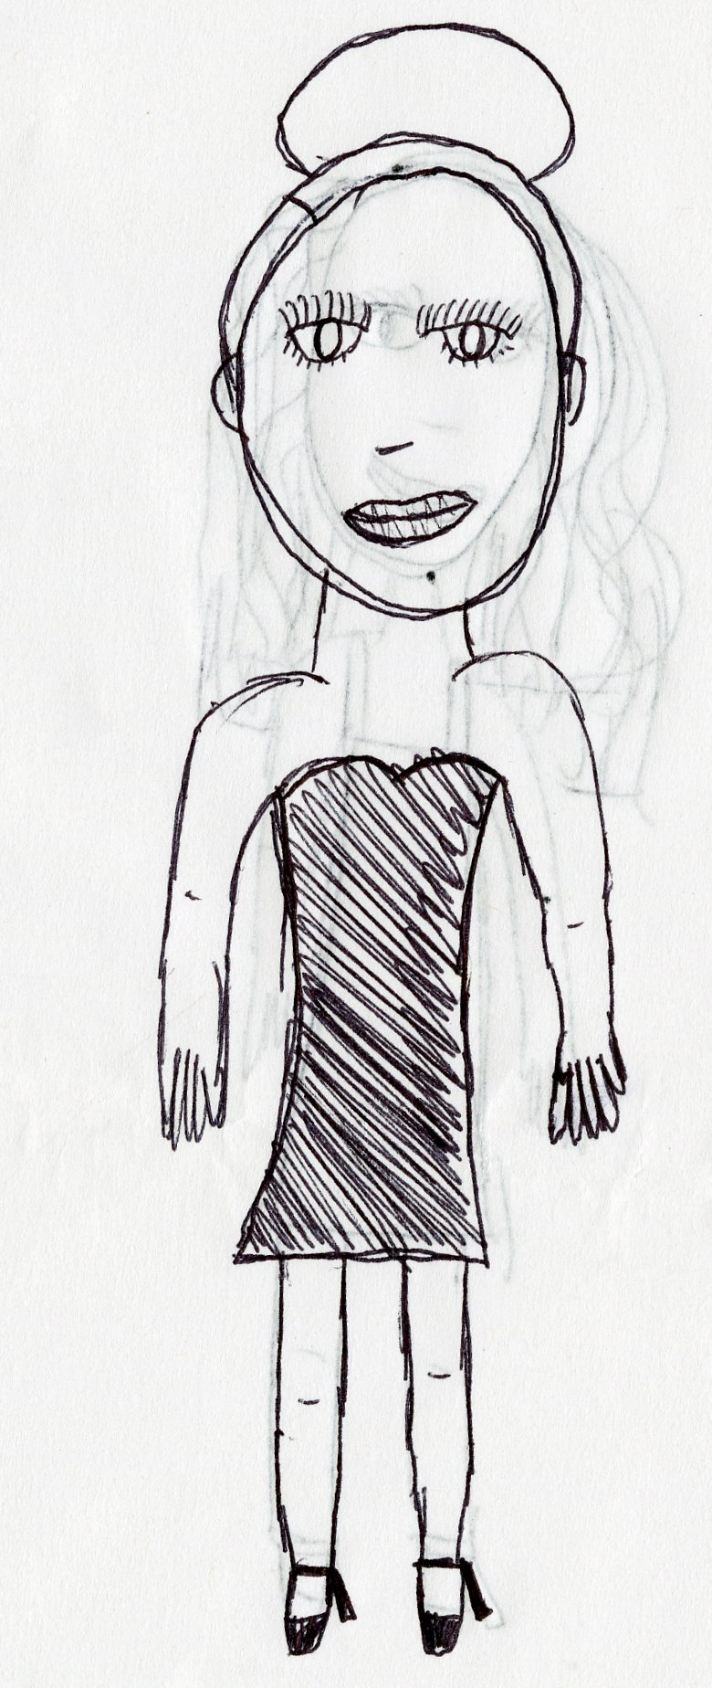

Participant 1 – After
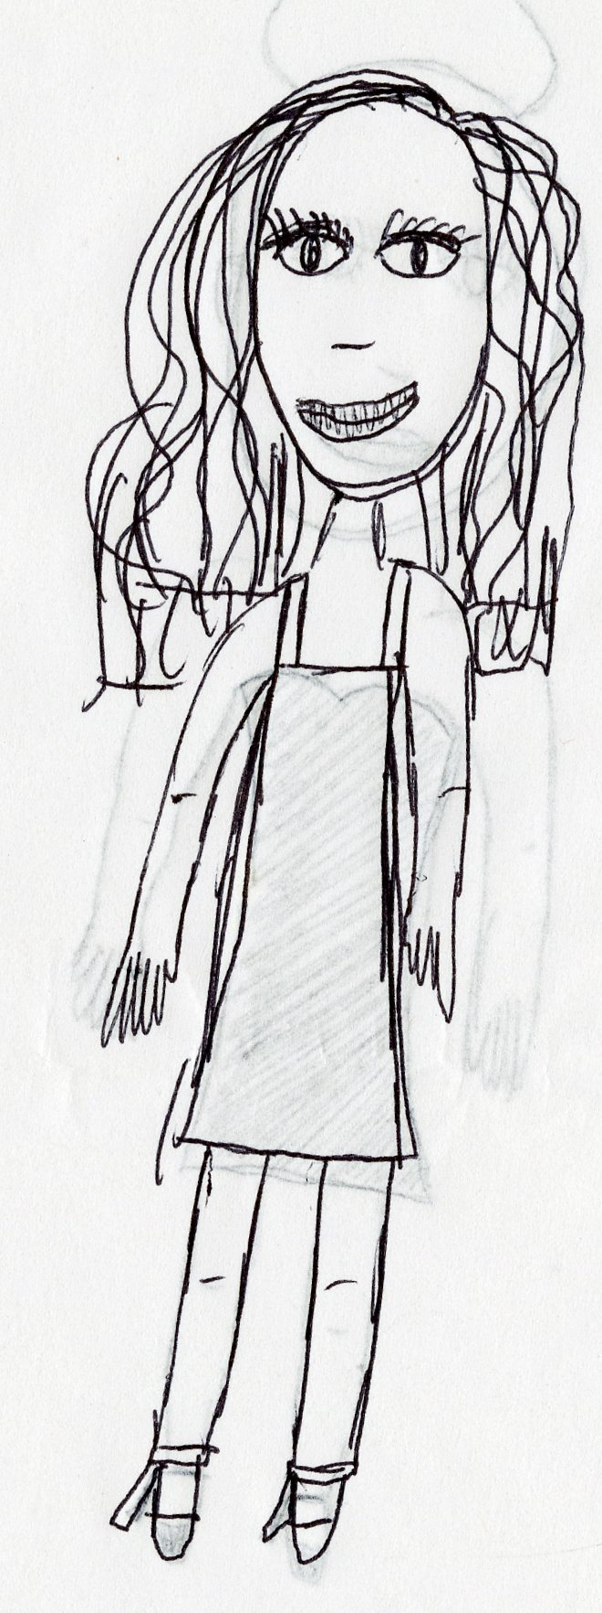

Participant 2 – Before 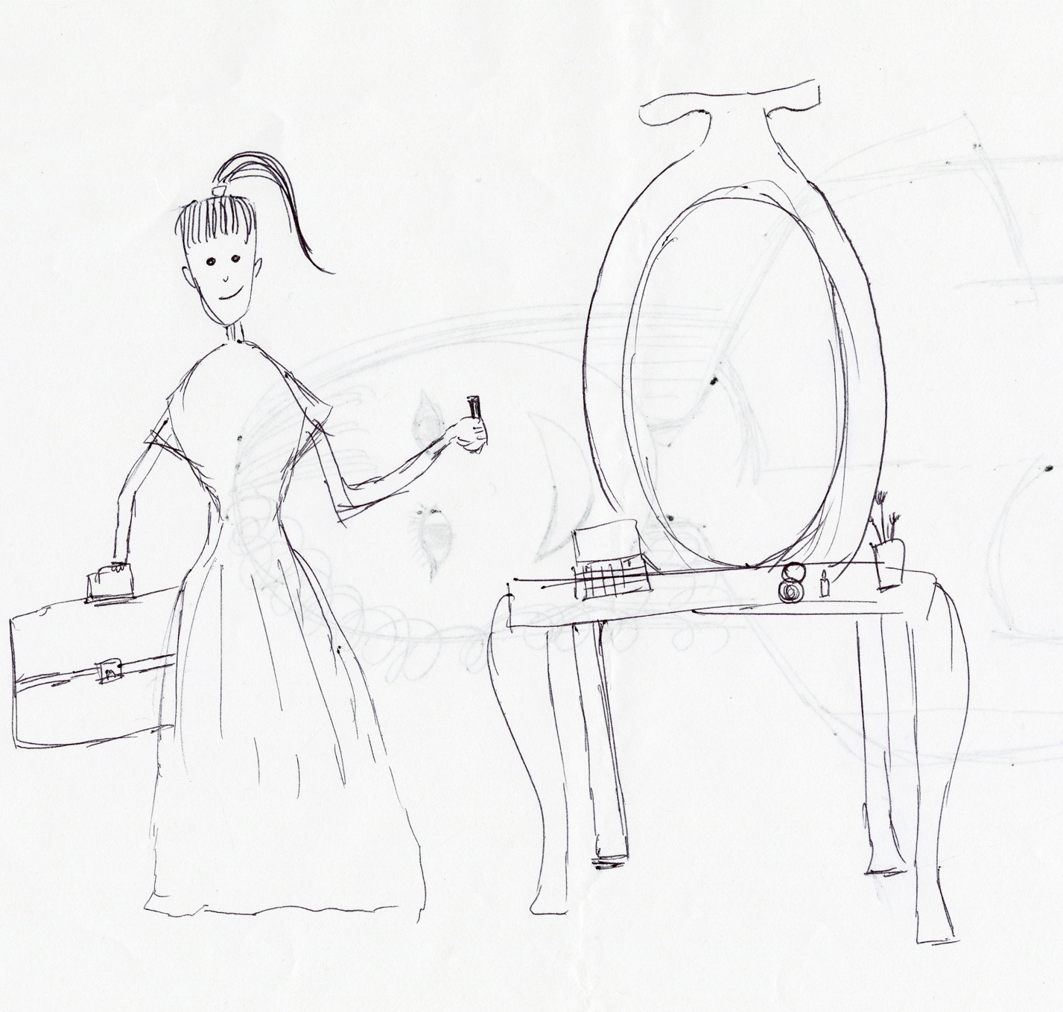

Participant 2 - After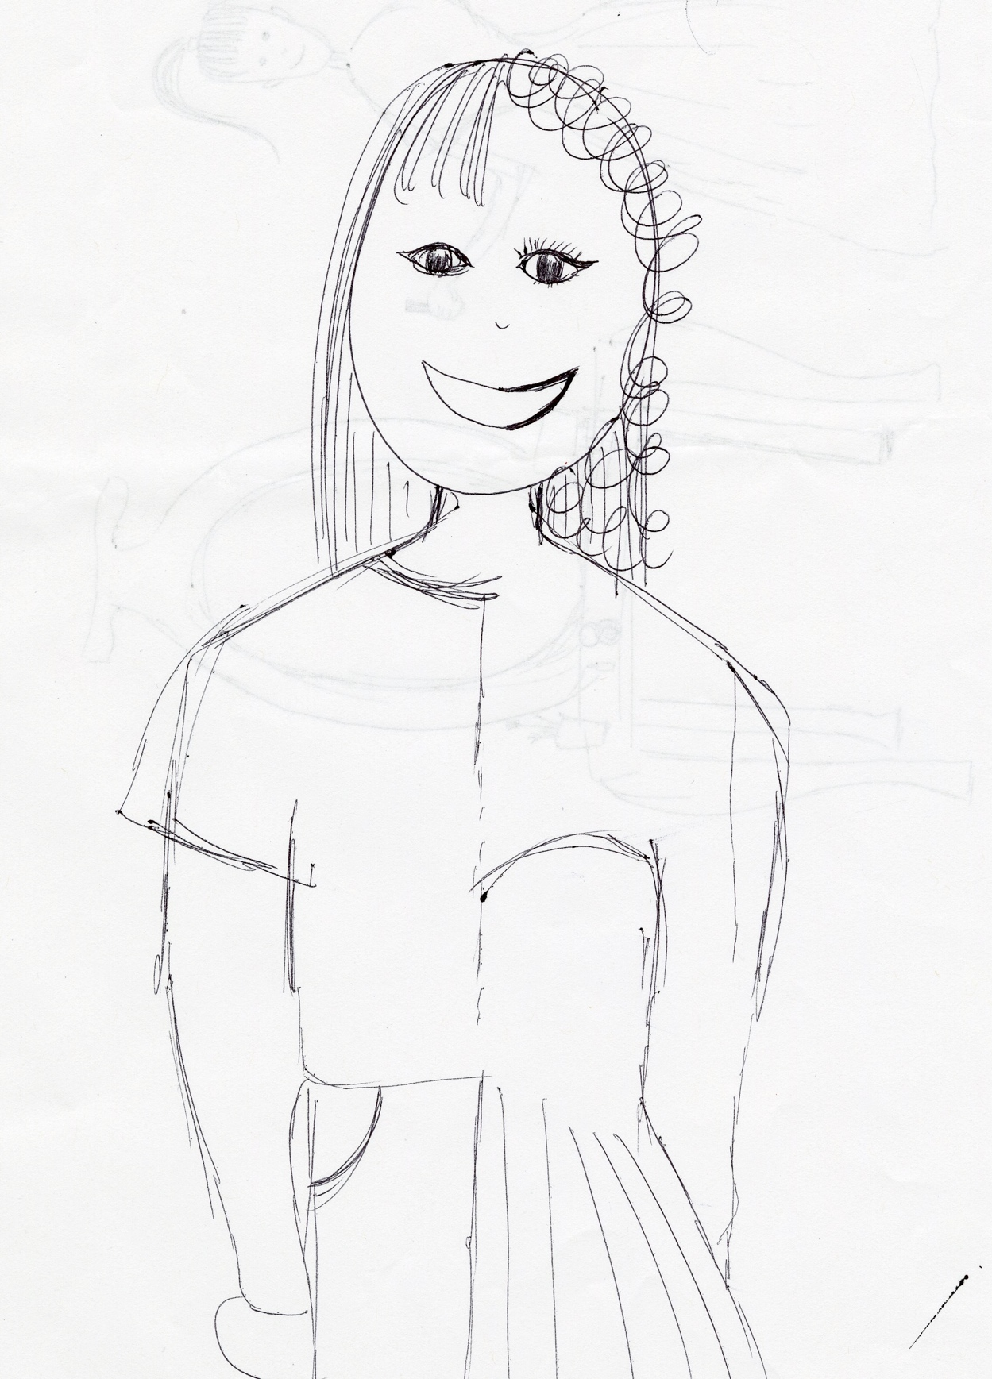

Participant 3 – Before
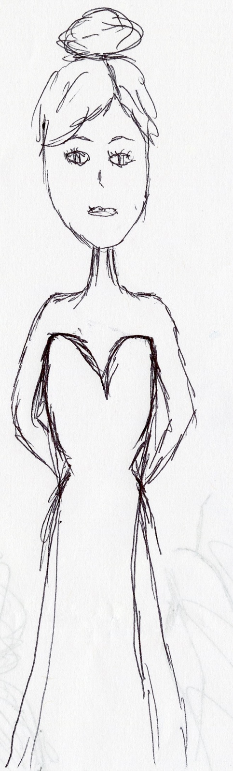

Participant 3 – After
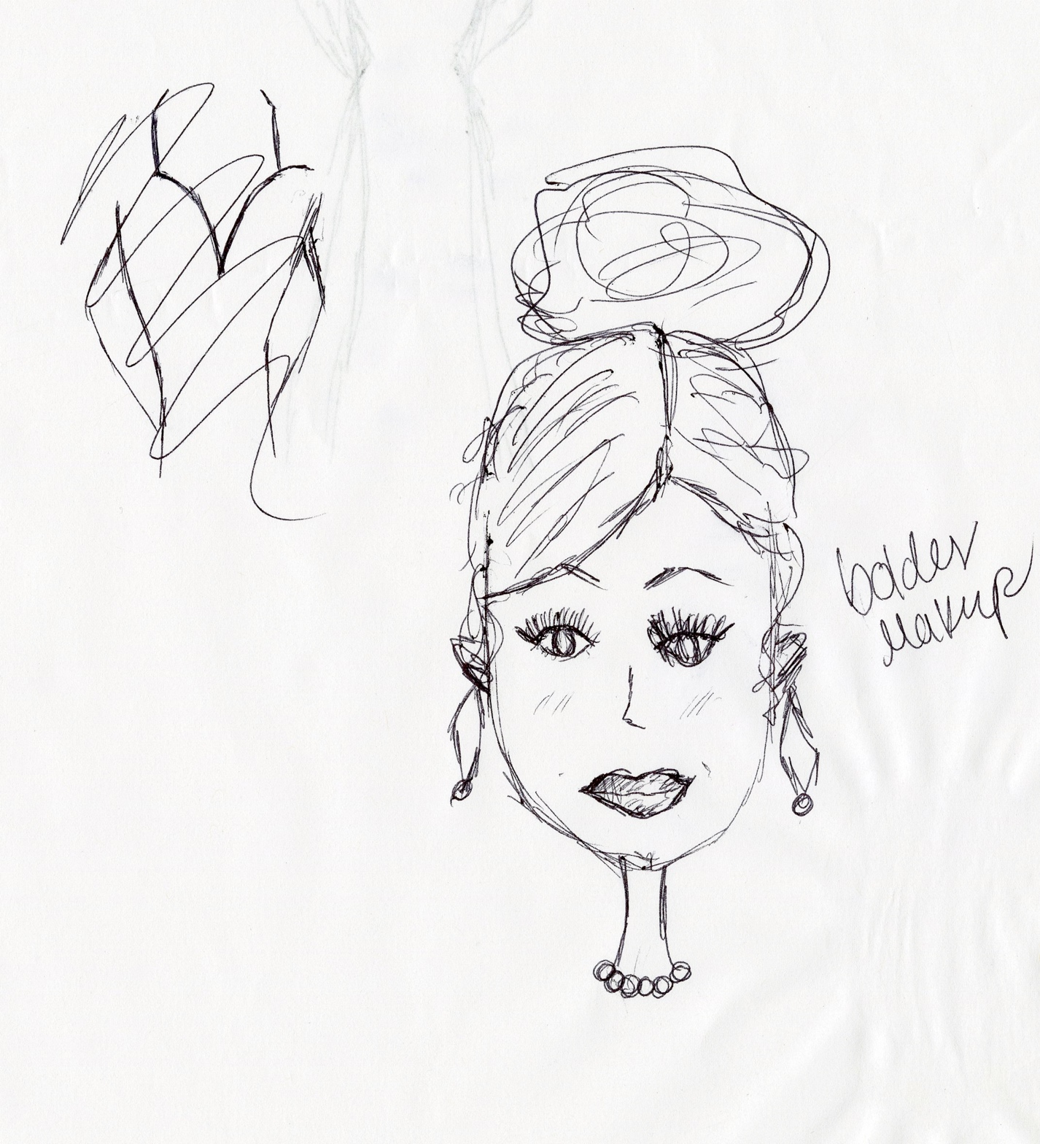

Participant 4 – Before

Participant 4 – After
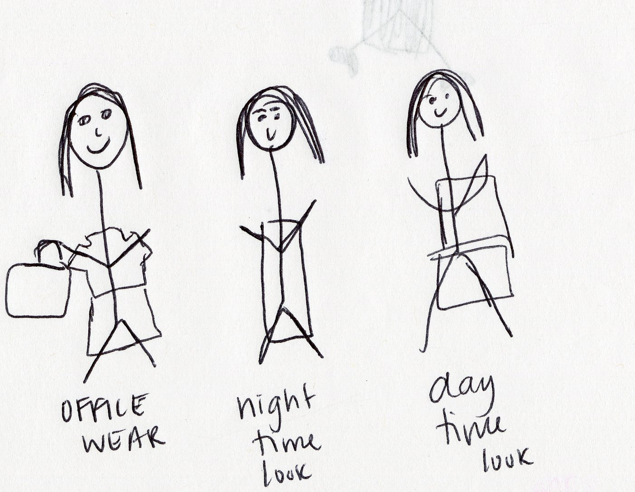

Participant 5 – Before
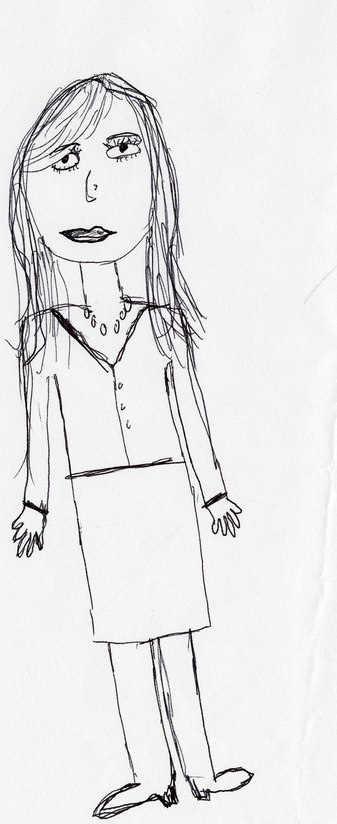

Participant 5 – After
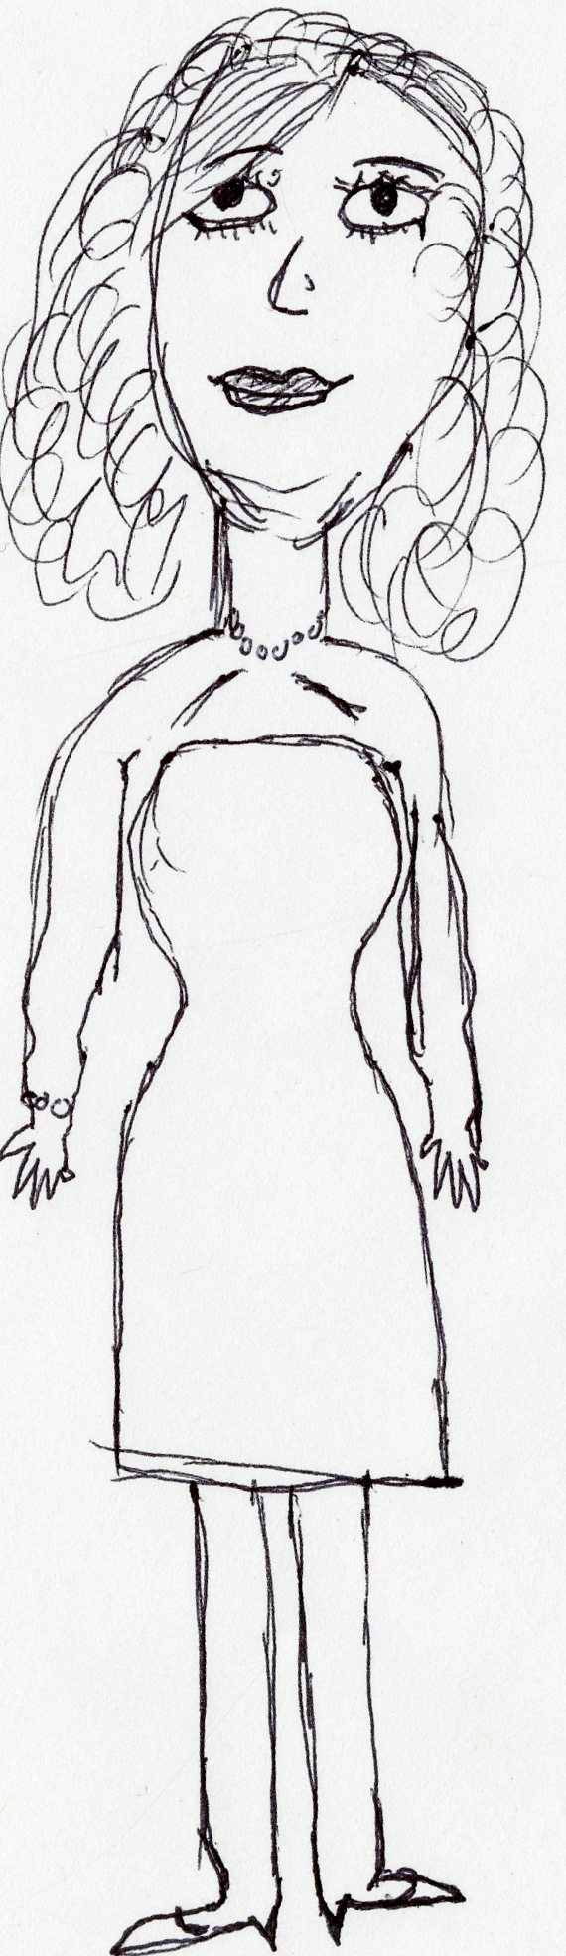

Participant 6 – Before
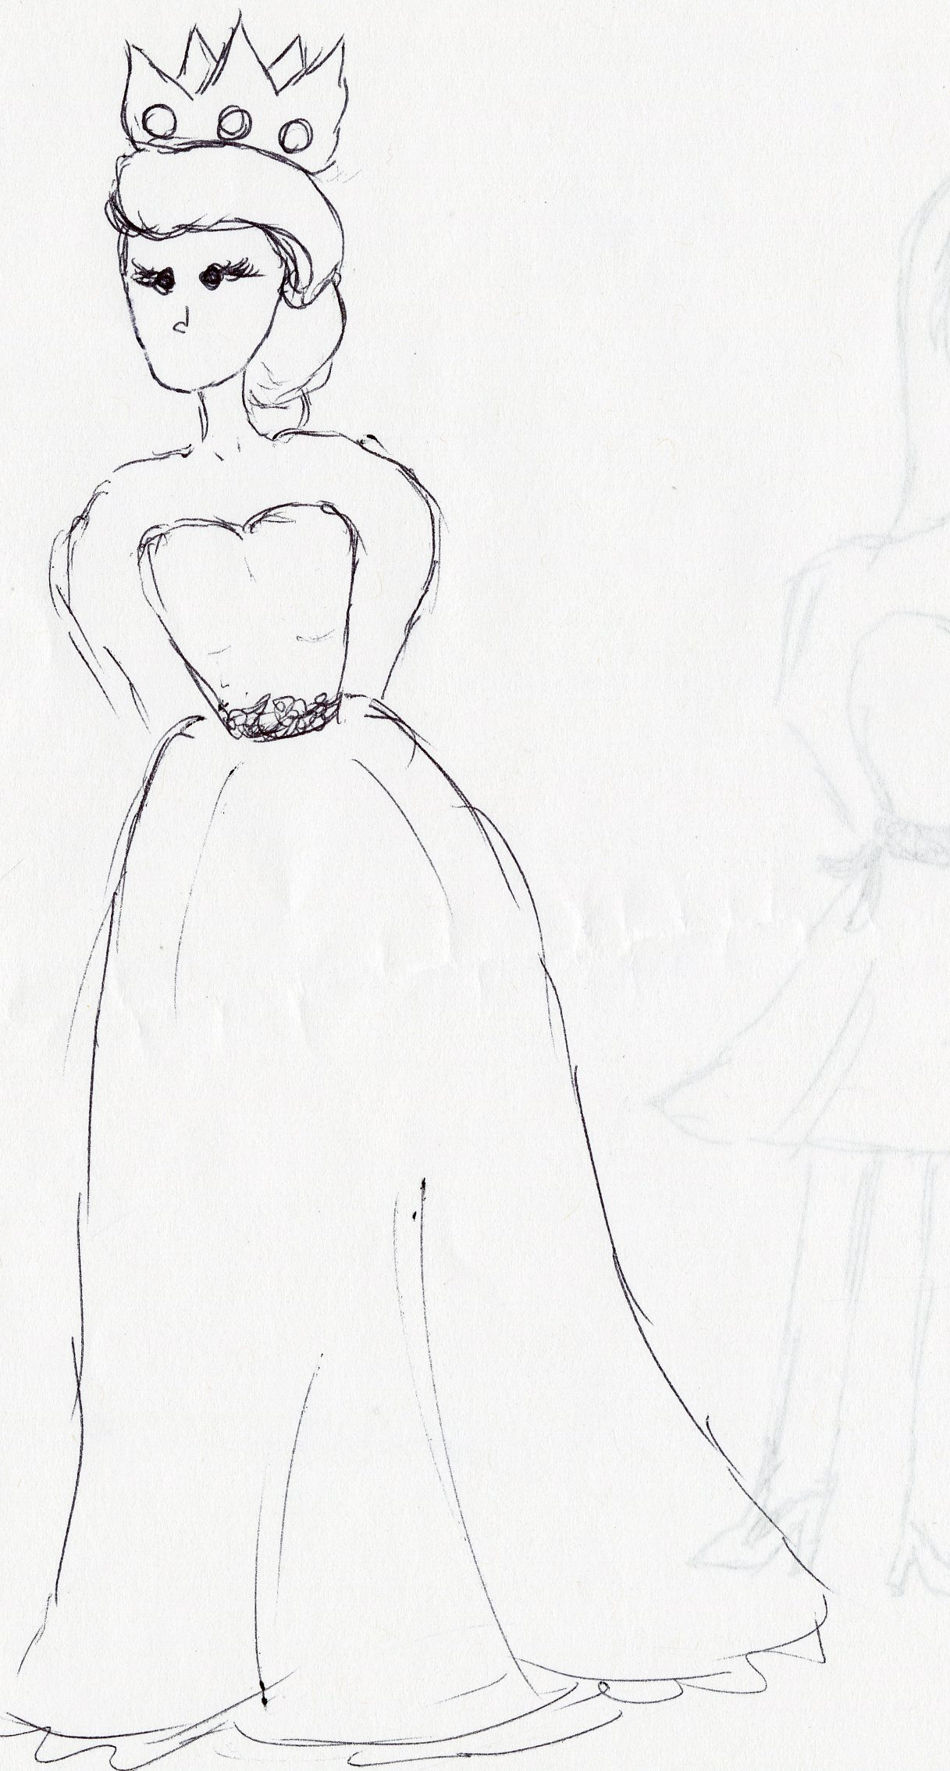

Participant 6 – After
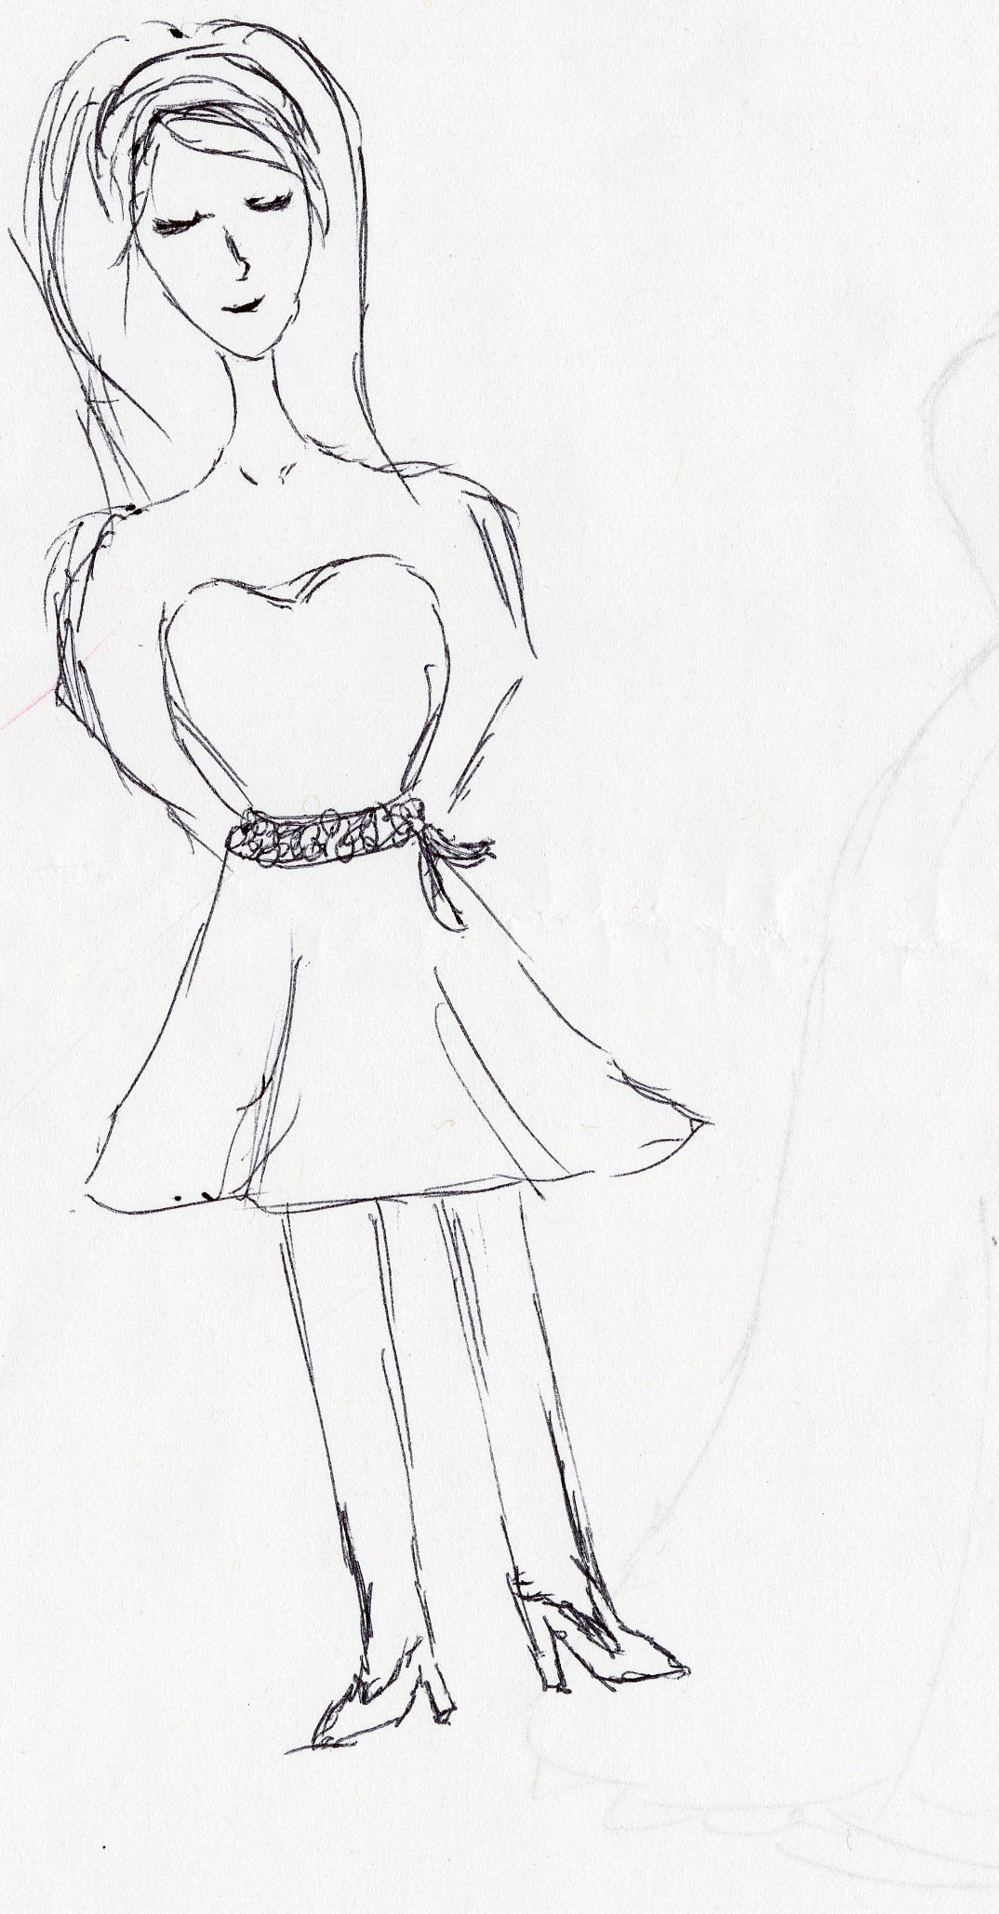

Participant 7 – Before
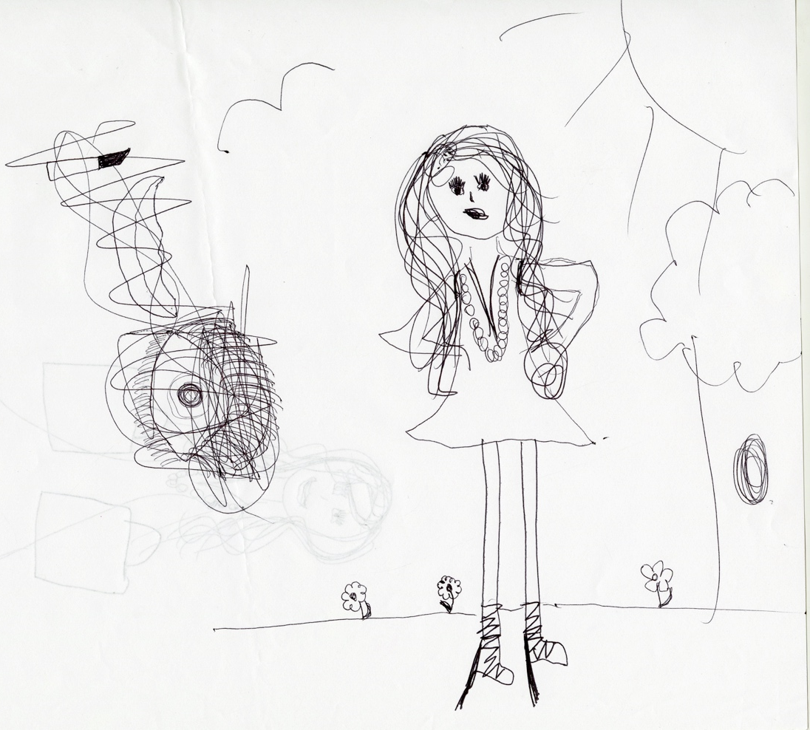

Participant 7 – After
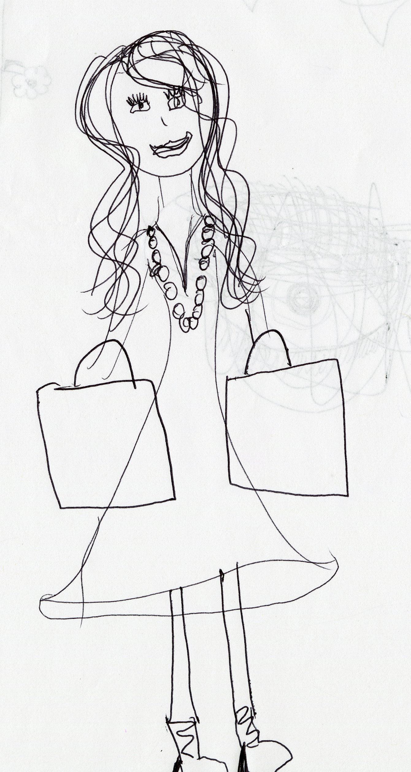

Participant 8 – Before
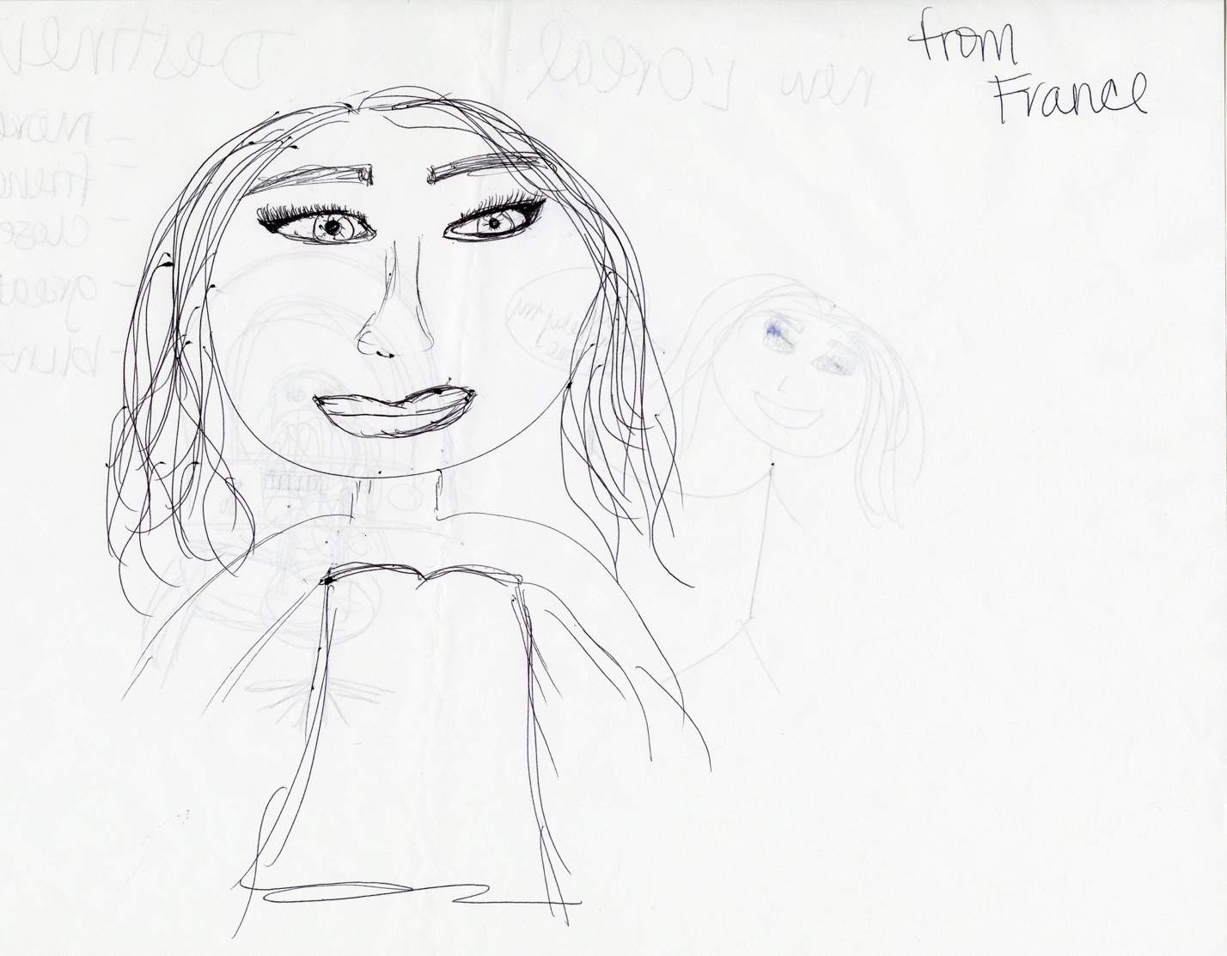

Participant 8 – After
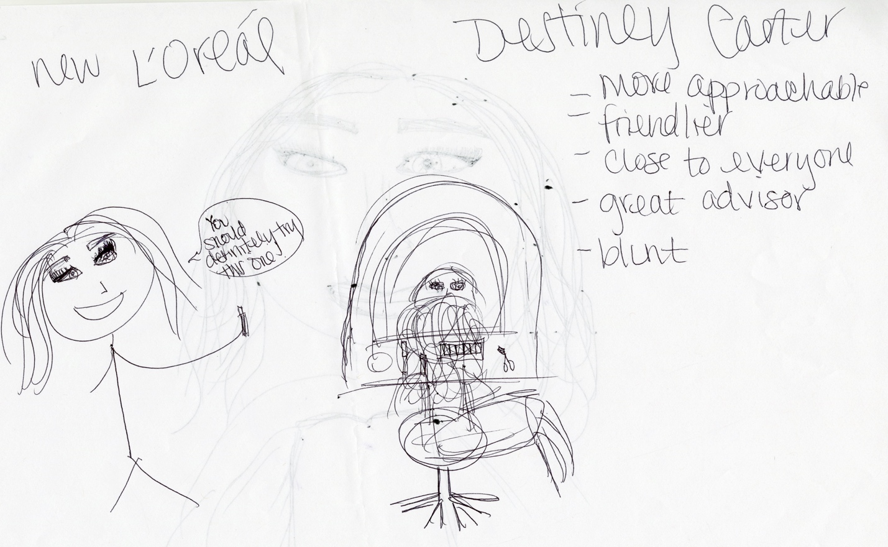

Competitor Customers:
Participant 1 –
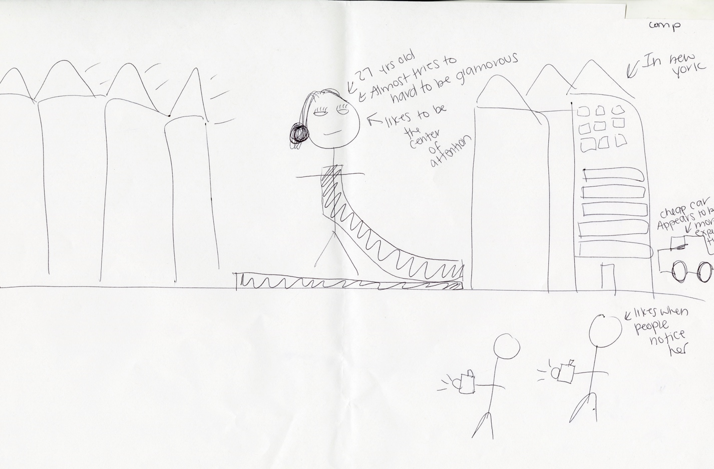

Participant 2 –
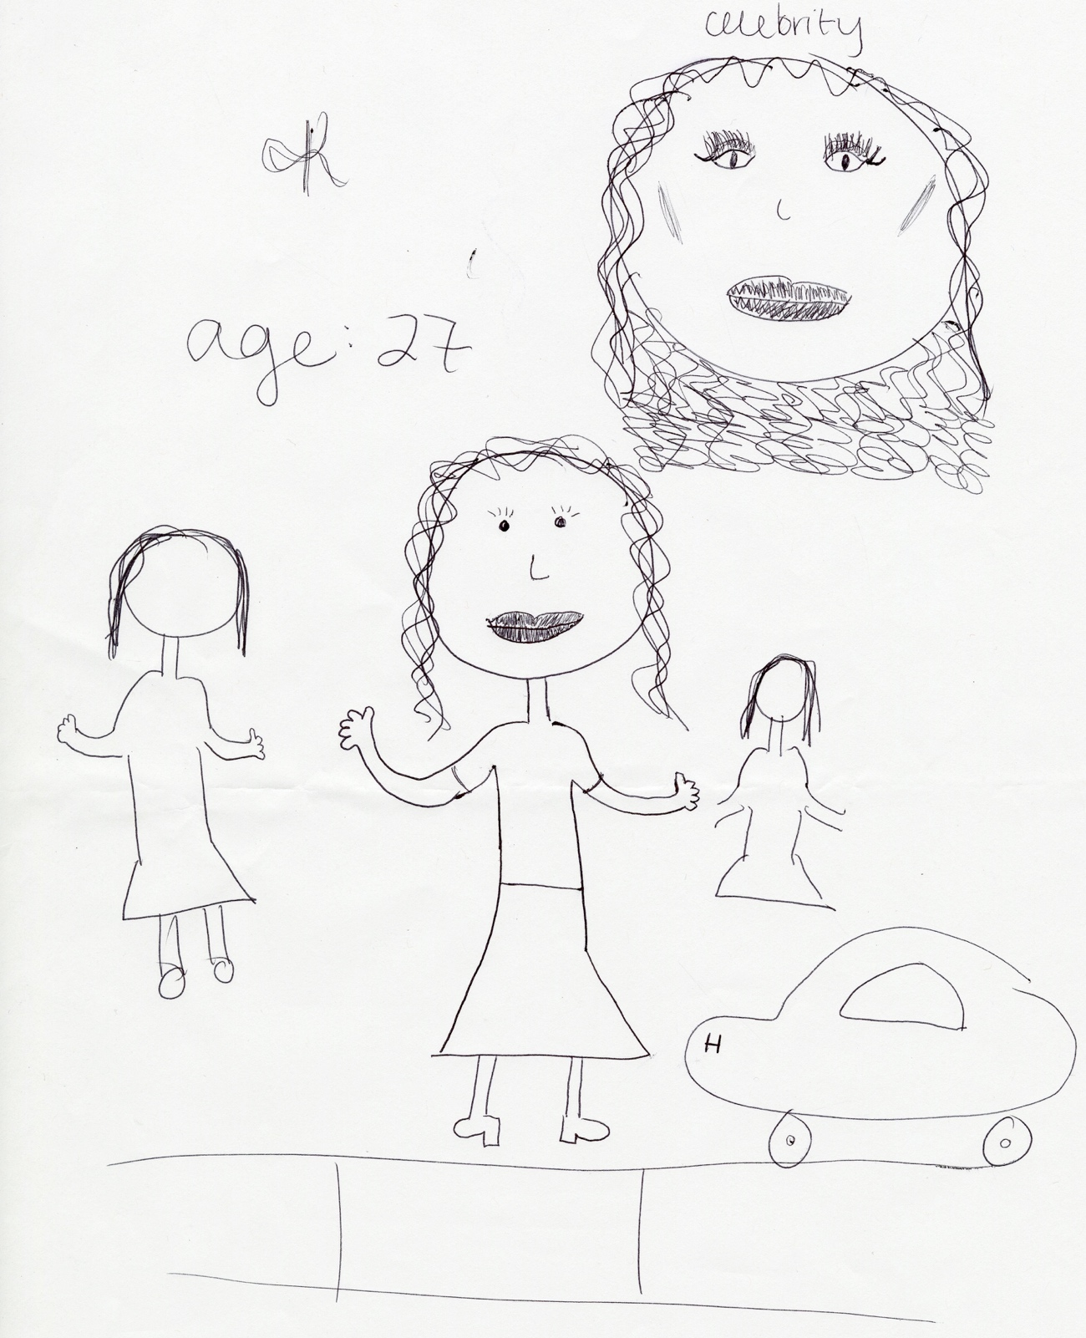

Participant 3 –
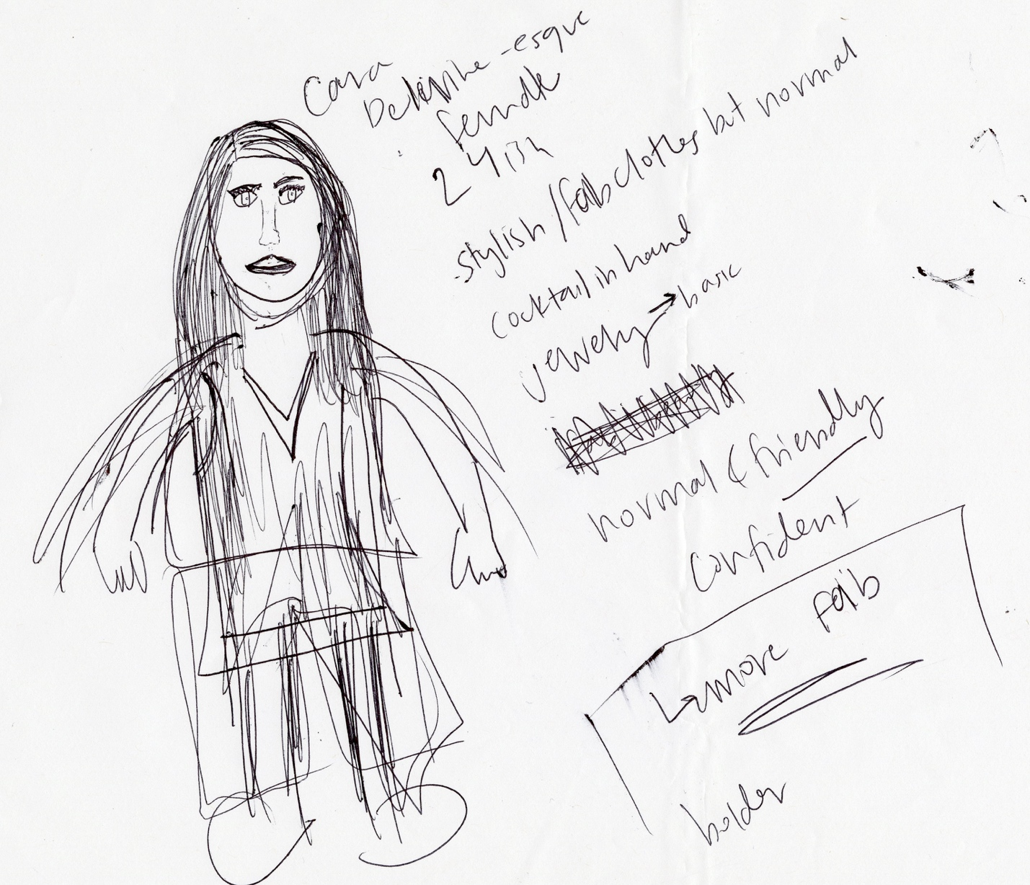

Participant 4 –
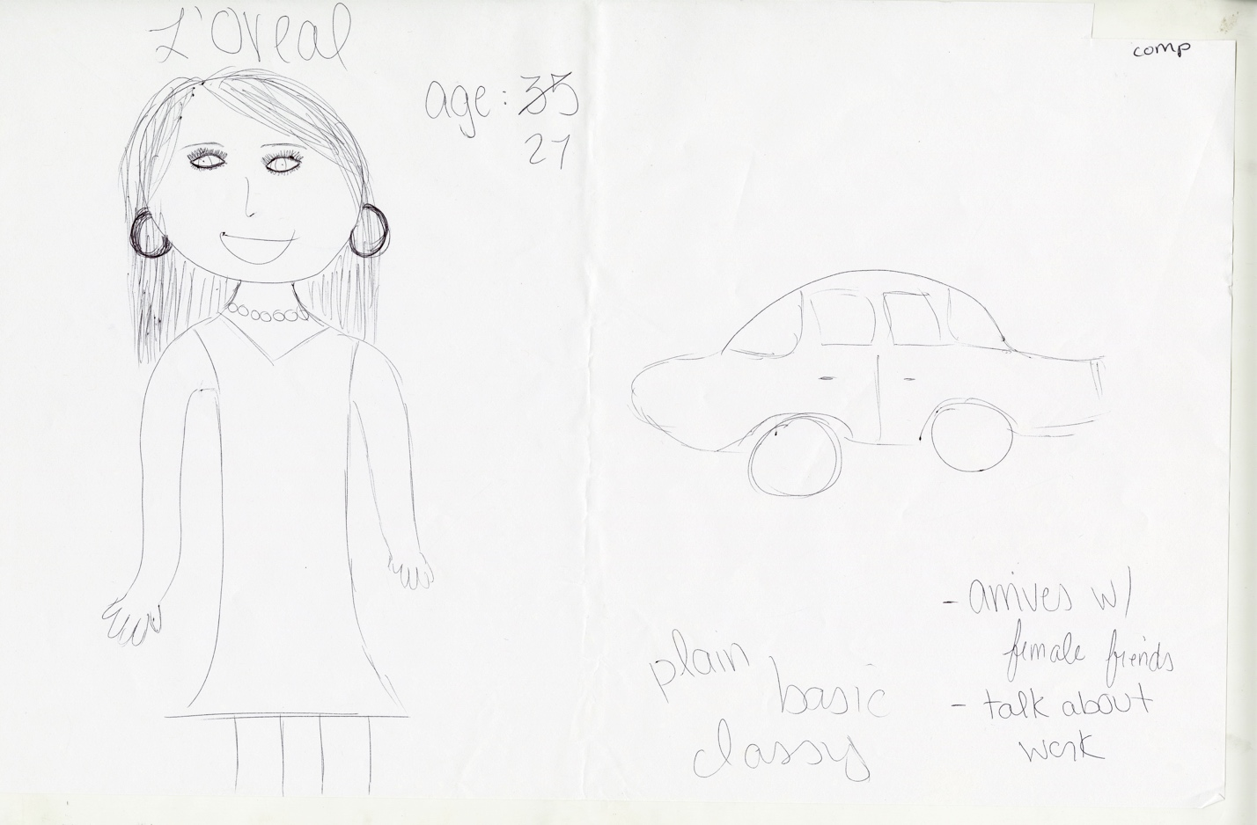

Participant 5 –
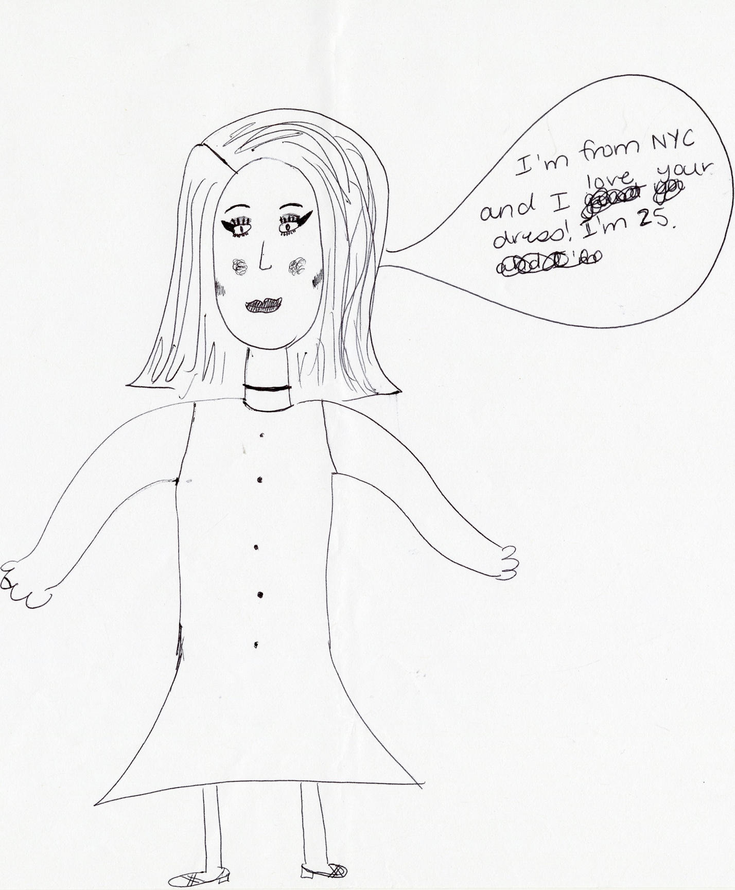

Participant 6 –
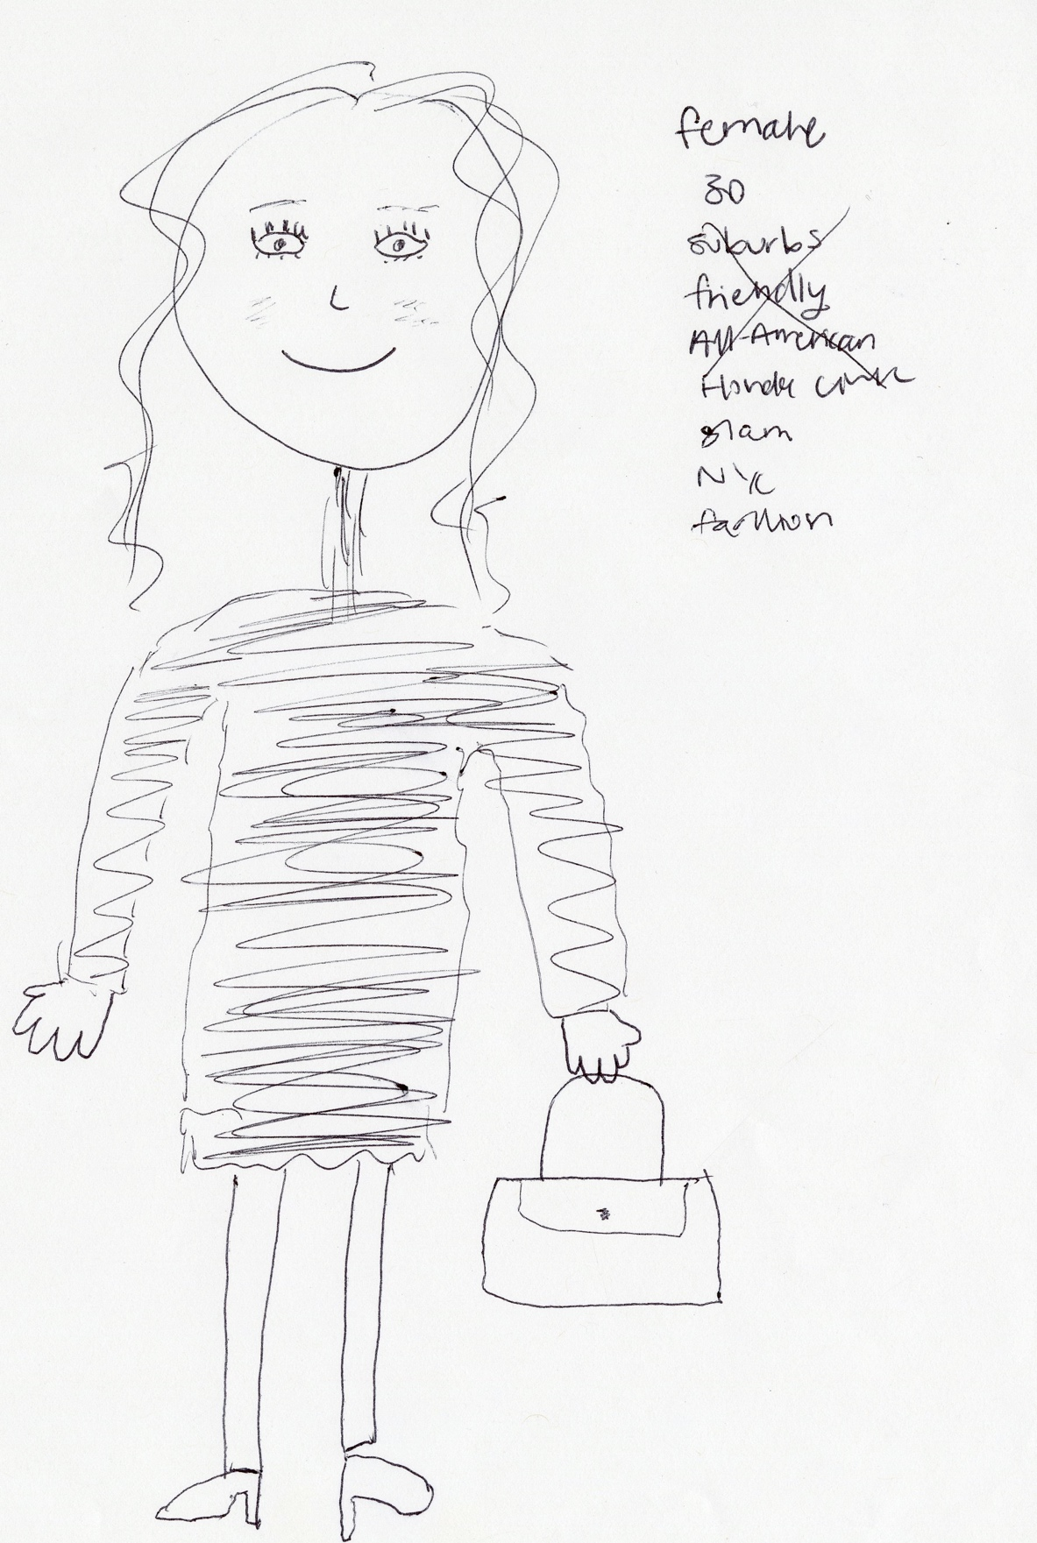

Participant 7 –
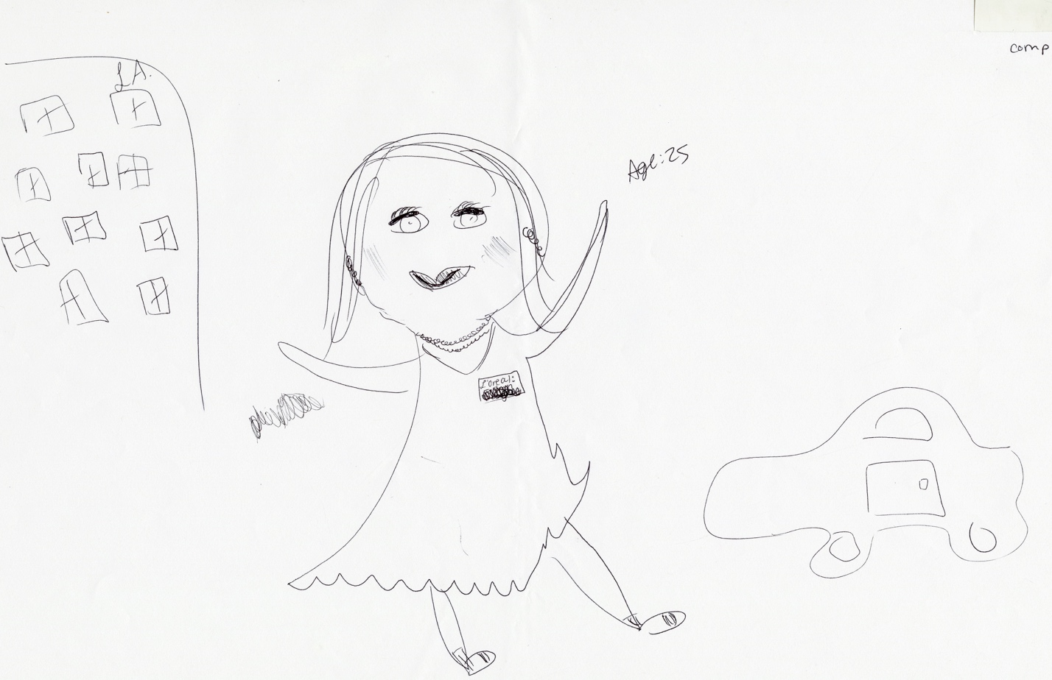

Non-Makeup Naturals:
Participant 1 – Before
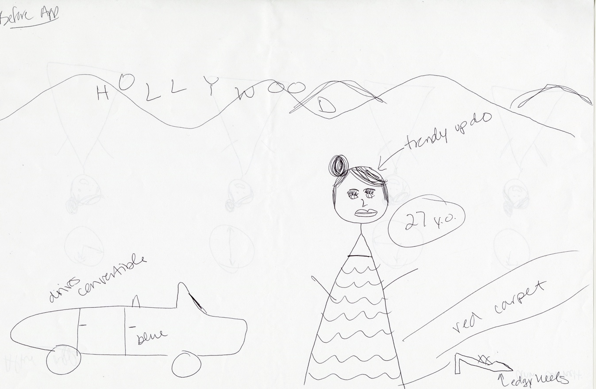
Participant 1 – After
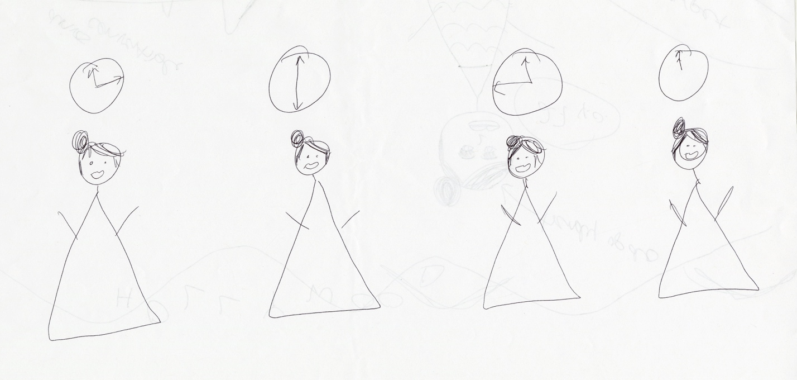

Participant 2 –
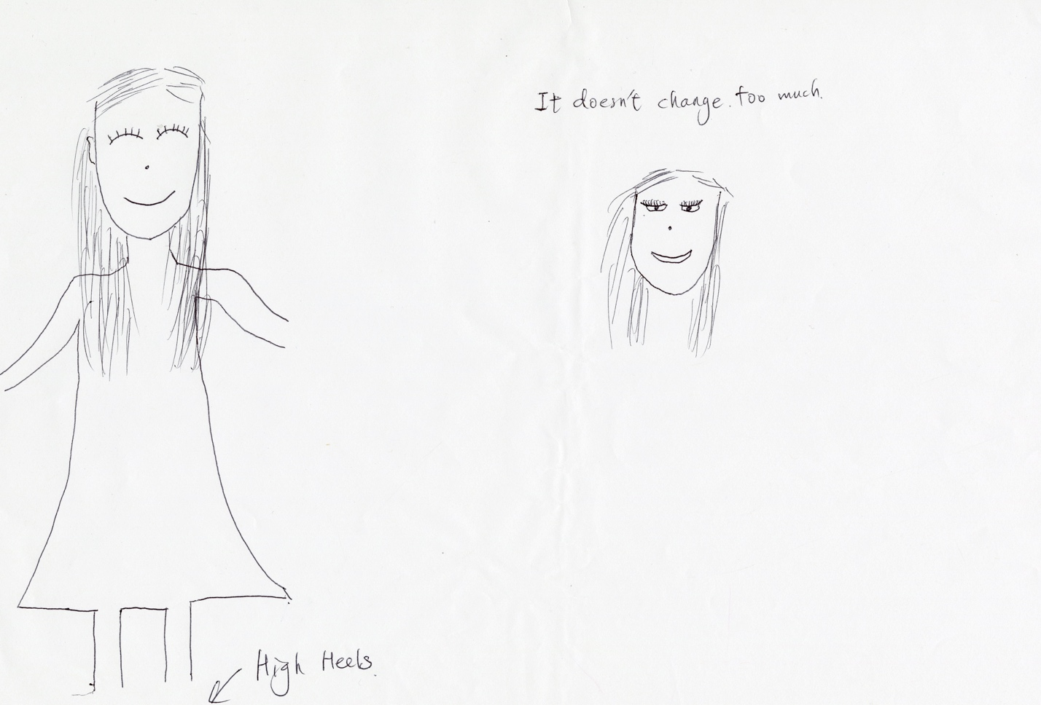

Participant 3 – Before
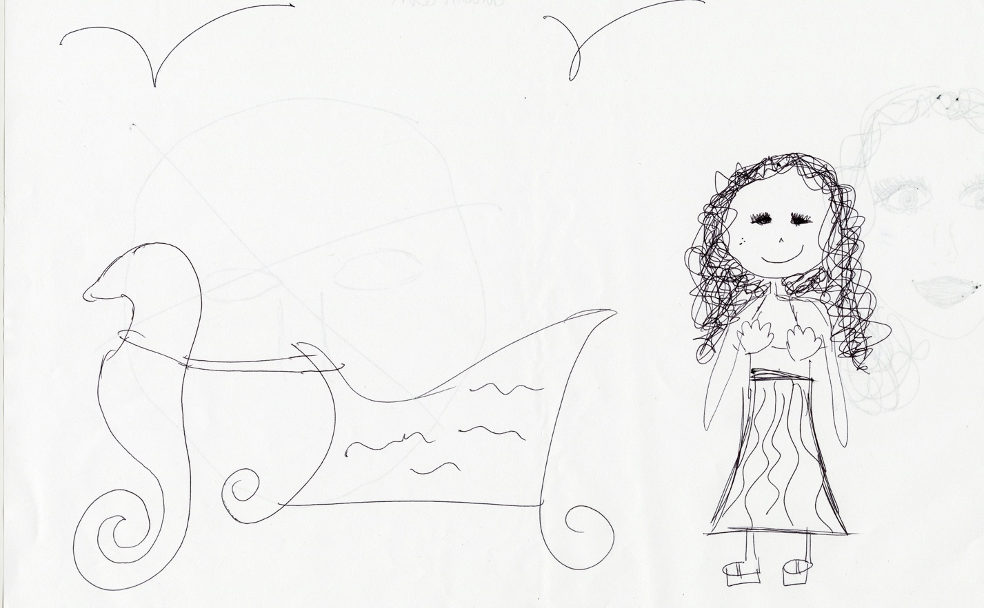

Participant 3 – After

Participant 4 –
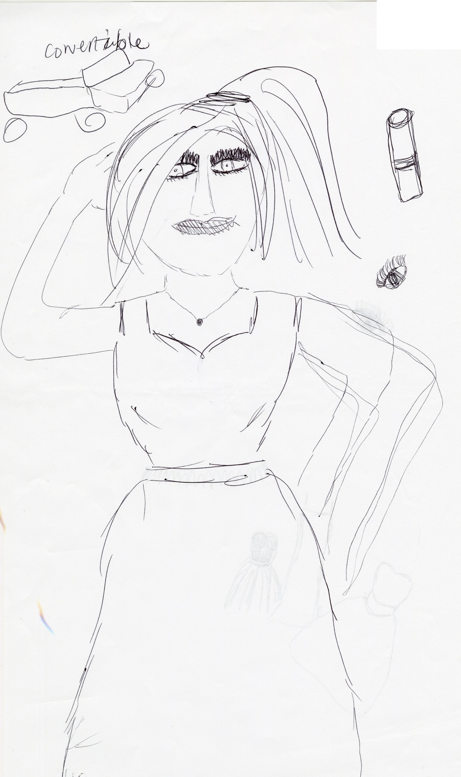

Participant 5 –
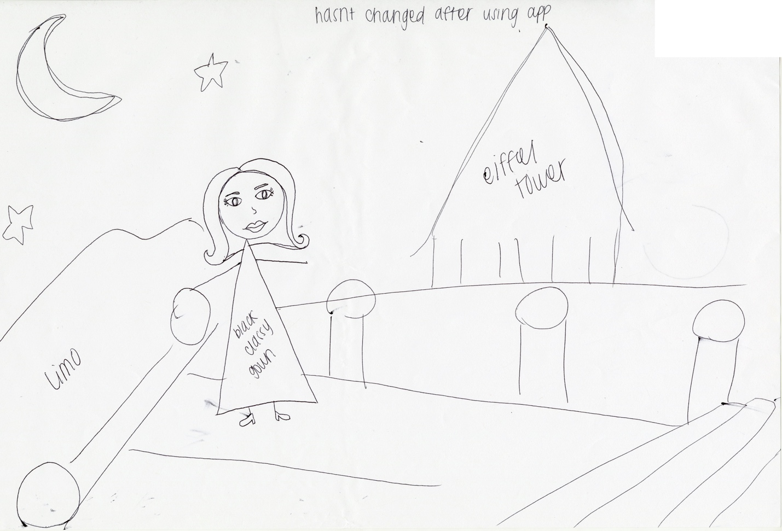

Participant 6 – Before

Participant 6 - After
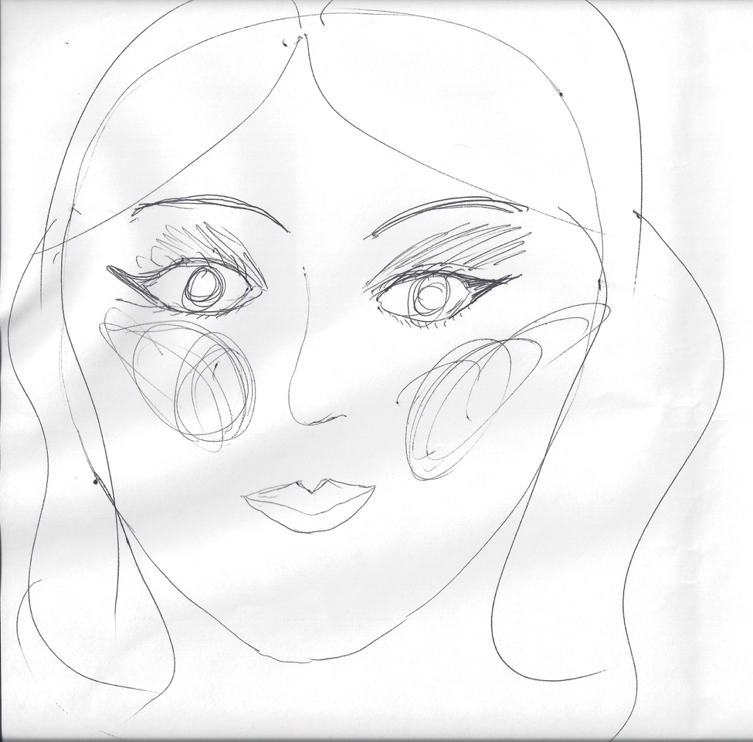

Participant 7 - Before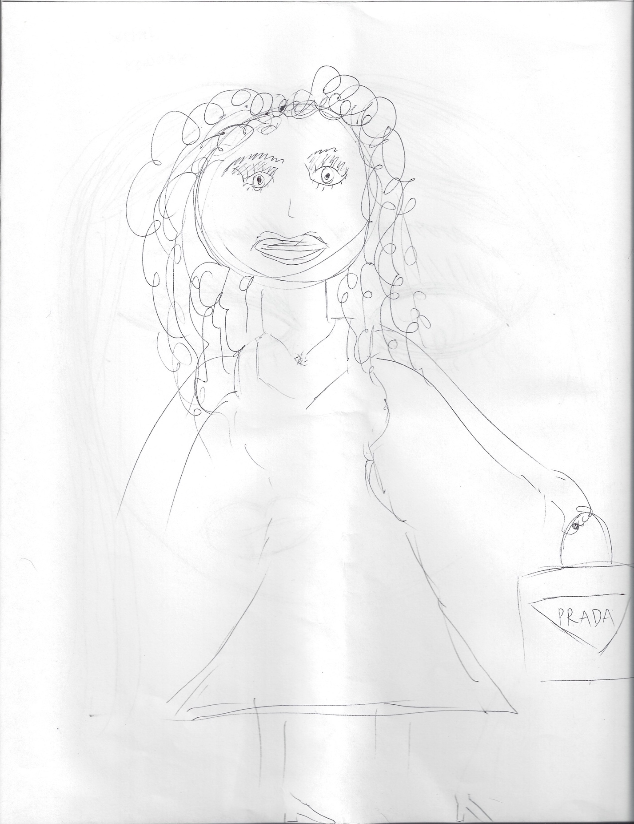

Participant 7 - After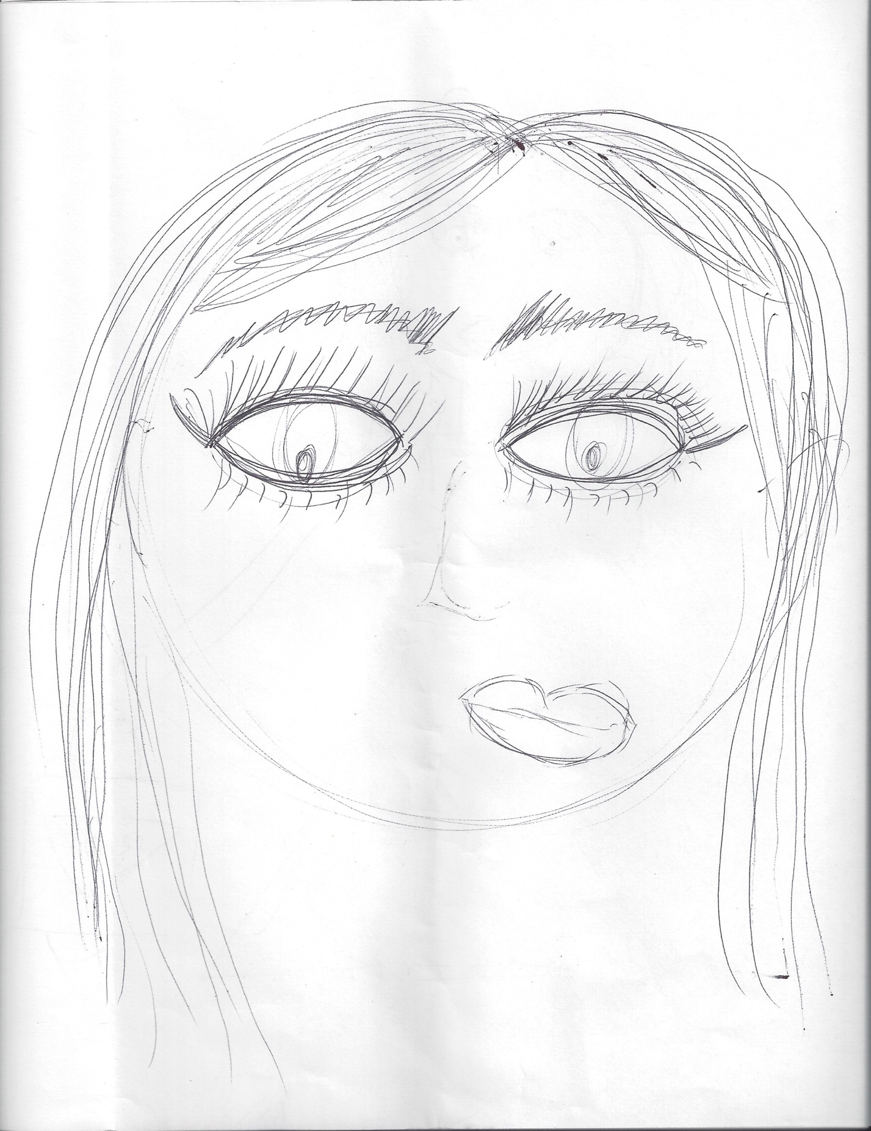

Participant 8 – Before

Participant 8 – After

Participant 9 - 